Sgt. Jay Ryan Gauthreaux

July 14, 1980 – December 4, 2006

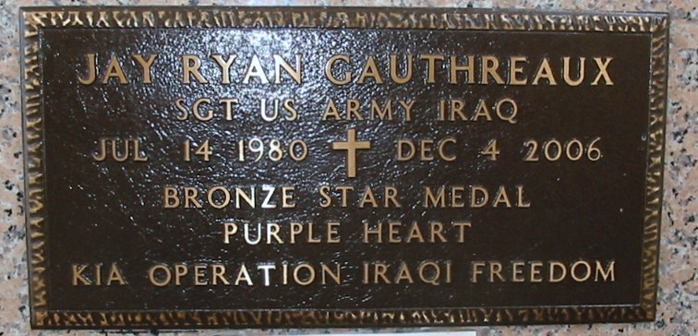

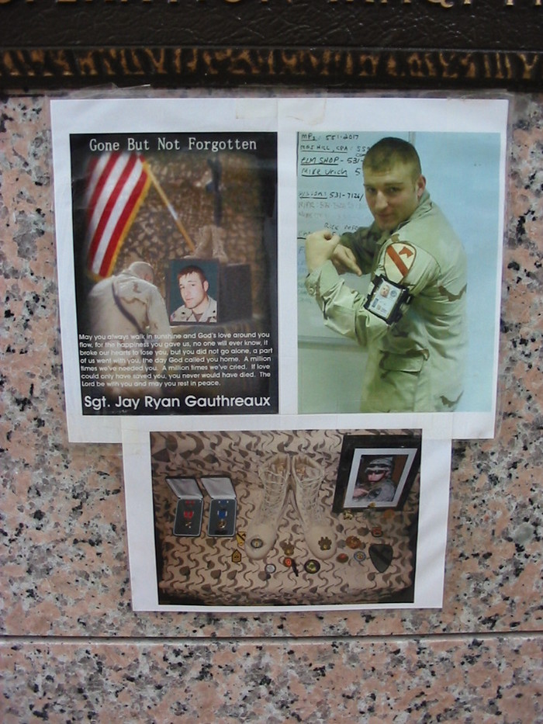

Photos by Bobby

The Department of Defense announced today the death of two soldiers who were supporting Operation Iraqi Freedom.

<snip>

Sgt. Jay R. Gauthreaux, 26, of Thibodaux, La., died Dec. 4 in Balad, Iraq, of injuries suffered in Baqubah, Iraq, when in improvised explosive device detonated near his vehicle while on patrol. Gauthreaux was assigned to the 3rd Heavy Brigade Combat Team, 1st Cavalry Division, Fort Hood, Texas. For additional information on Gauthreaux's death the media can contact the Fort Hood public affairs office at (254) 287-9993.

US Dept of Defense; Immediate Release: December 8, 2006

\*\*\*\*\*

Army Sgt. Jay R. Gauthreaux

Died December 4, 2006 Serving During Operation Iraqi Freedom

26, of Thibodaux, La.; assigned to the 3rd Heavy Brigade Combat Team, 1st Cavalry Division, Fort Hood, Texas; died Dec. 4 in Balad, Iraq, of injuries sustained in Baqubah, Iraq, when in improvised explosive device detonated near his vehicle while on patrol.

Military Times; Honor the Fallen

\*\*\*\*

Army SGT Jay R. Gauthreaux, 26, of Thibodaux, Louisiana. Died December 4, 2006, serving during Operation Iraqi Freedom. Assigned to 3rd Heavy Brigade Combat Team, 1st Cavalry Division, Fort Hood, Texas. Died in Balad, Salah ad Din Province, Iraq, of injuries sustained when an improvised explosive device detonated near his vehicle while on patrol during combat operations in Baqubah, Diyala ...