Henry Gibson Sr.

January 20, 1929 – April 4, 2003

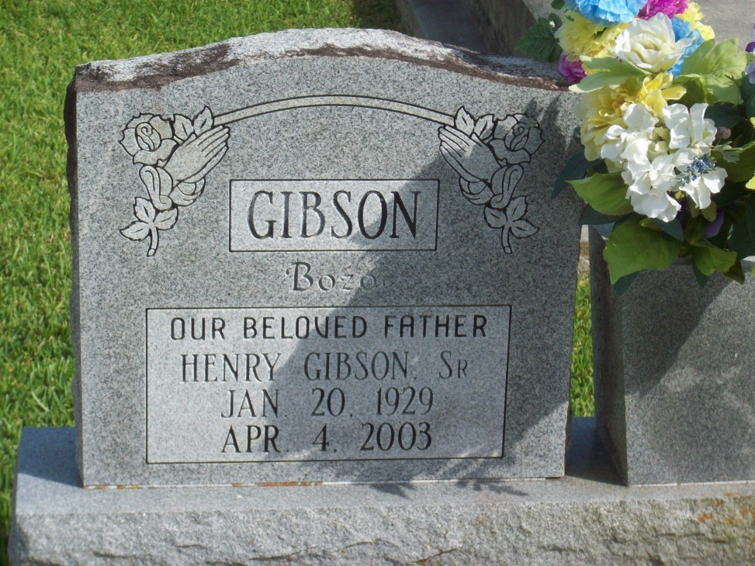

Photo by TMB

Henry "Bozo" Gibson Sr., a retired laborer, died Friday of congestive heart failure at Thibodaux Regional Medical Center. He was 74. Mr. Gibson was a lifelong resident of Vacherie. Survivors include five sons, Charles, Jerome, Mark, Michael and Henry Gibson Jr.; six daughters, Shelia G. Roussell, Valerie G. Simon, Cynthia G. Arnold, Melanie Boudreaux, Mary Gibson and Charlene G. Hickerson; a brother, Coleman Gibson; six sisters, Florida Carey, Angie Brown, Miami Williams, Dolores Schexnayder, Gloria Fuller and Janet Johnson; 17 grandchildren; and 10 great-grandchildren. A Mass will be said Saturday at 10 a.m. at St. Philip Catholic Church in Vacherie. Visitation will begin at 8 a.m. Burial will be in Our Lady of Peace Cemetery. D.W. Rhodes Funeral Home is in charge of arrangements.

Times-Picayune, The (New Orleans, LA) - Friday, April 11, 2003

Contributed by Jane Edson