Mindi Marie (Becnel) Gordon

June 10, 1981 – July 20, 2019

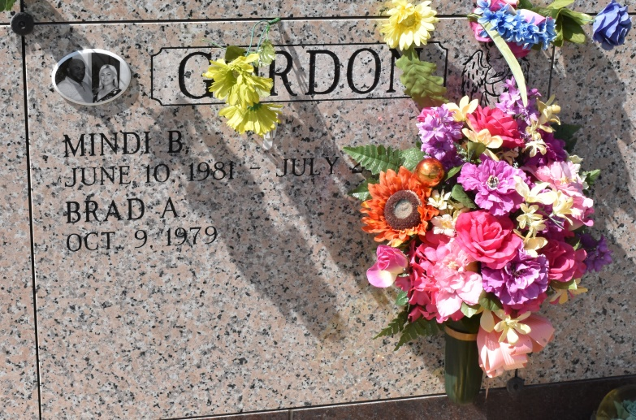

Mindi Marie Becnel Gordon, 38, gained her eternal wings on July 20, 2019. Born June 10, 1981, she was a native of Vacherie and resident of Boutte. Visitation will be held from 9 a.m. until service time on Friday, July 26 at Our Lady of Peace Catholic Church. Mass of Christian Burial will begin at noon at the church. Burial will follow in the church cemetery. She is survived by her husband, Brad Gordon; daughters, Ashlyn De'Jae Gordon and Allanah Nicole Gordon; mother, Heidi Suski Becnel; father, Wilson Becnel and stepmother, Angel Becnel; brothers, Travis James Becnel and wife, Kylee Becnel, and Justin Wilson Becnel and wife, Tereva Becnel; sisters, Monica Boudreaux and husband, Benji, and Tina Rodrigue and husband, Linus; mother-in-law, Althea Gordon; sister-in-law, Jaranea Gordon; and numerous nieces and nephews. She was preceded in death by her grandparents, Olga R. Becnel and Joseph G. Becnel, and Phyllis A. Suski and Stanley R. Suski. Mindi worked as a medical assistant at West Jefferson Medical Center. Her hobbies included cosmetology, arts and crafts. She had a great love of all animals and always enjoyed her music. She was dearly loved by all of her family and friends. She will be greatly missed by all who knew her. Ordoyne Funeral Home is in charge of arrangements.

Houma Today & The Daily Comet (LA)

July 23 to July 24, 2019