Joseph Albert Granier Sr.

February 3, 1912 – February 6, 2000

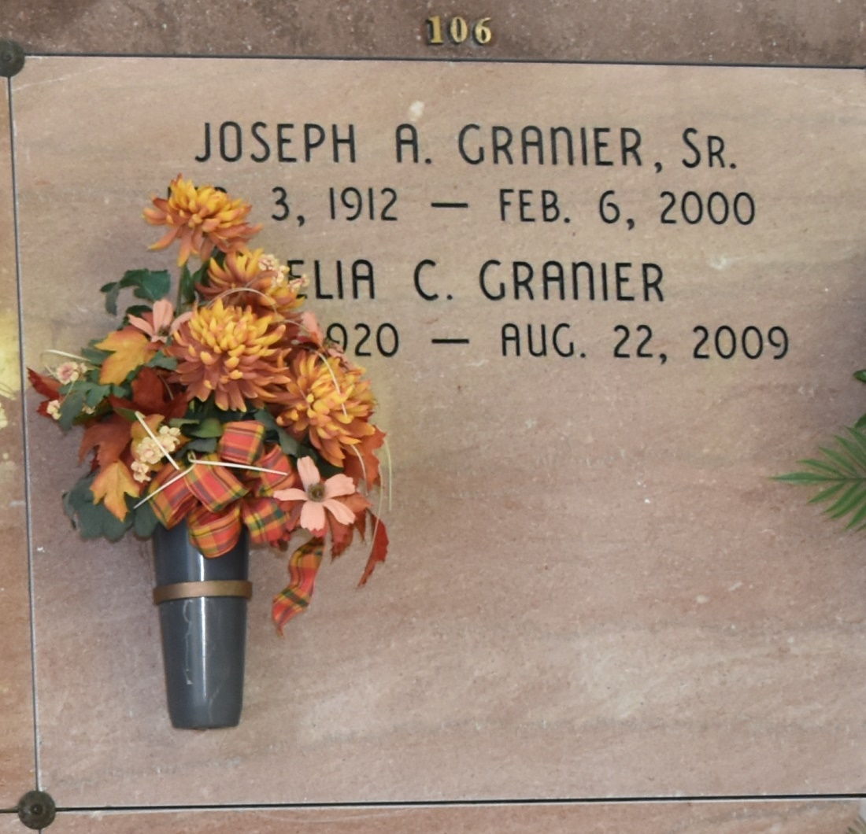

Retired principal of Vacherie Elementary School with 35 years of service, he died at 7:45 a.m. Sunday, Feb. 6, 2000, in Donaldsonville. He was 88, a longtime resident of St. James, a resident of Donaldsonville for the past 3½ years and a native of Iberville Parish. Visiting at St. Francis of Assisi Catholic Church, Donaldsonville, from 8 a.m. until Mass of Christian Burial at 11 a.m. Tuesday, celebrated by the Rev. Michael Galea. Entombment in Our Lady of Peace Mausoleum, Vacherie. Survived by his wife of 61 years, Lelia Charlet Granier, Donaldsonville; two daughters, Juanita G. Quaid, Donaldsonville, and Janet G. Boza, Tampa, Fla.; three sons, Joseph Granier Jr., Baton Rouge, David Granier, Vacherie, and Richard Granier, Arvada, Colo.; two sisters, Stella G. Gravois, Baton Rouge, and Evelyn G. Comeaux, Oakdale; a brother, Luke Granier Jr., St. James; 10 grandchildren; and two great-grandsons. Preceded in death by his parents, Luke Sr. and Mary Thibodeaux Granier; two sisters; and four brothers. Before his retirement from the St. James Parish School Board, he served for several years as supervisor of the child welfare and attendance program. Special thanks to Dr. Chester Weimer and staff. Ourso Funeral Home, Donaldsonville, in charge of arrangements.

Advocate, The (Baton Rouge, LA) - Monday, February 7, 2000  
Contributed by Jane Edson