Leopold Paul Jr.

November 4, 1949 – July 18, 2009

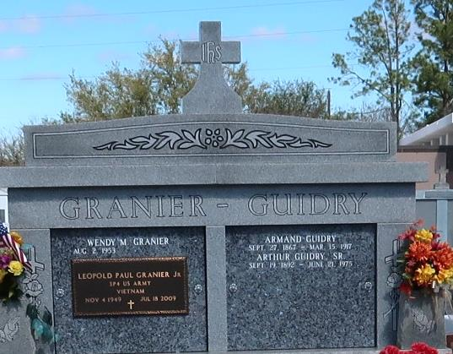

U.S., Obituary Collection, 1930-Current

Name: Leo T- Paul Granier Jr

Gender: Male

Death Age: 59

Birth Date: abt 1950

Residence Place: Chackbay, Vacherie

Death Date: 18 Jul 2009

Burial Place: Vacherie

Obituary Date: 21 Jul 2009

Father: Leopold Granier

Spouse: Wendy Matherne Granier

Child: Theresa Benoit, Fay Meaux

Siblings: Vaughn Granier, Elaine Falcon