Helen Eugenie (Reulet) Gravois

November 7, 1915 – May 29, 2009

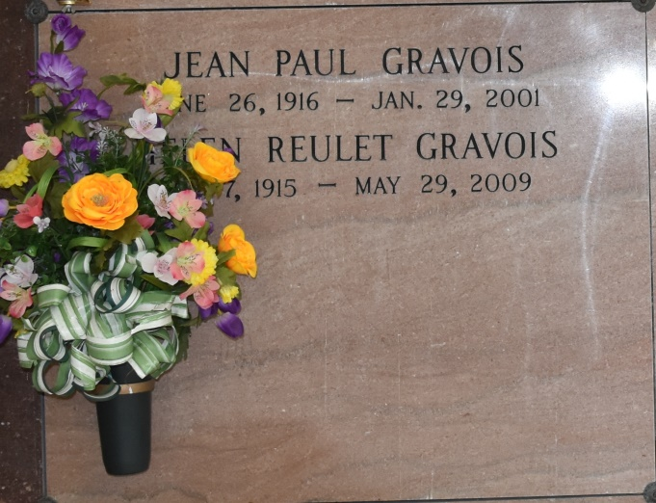

Helen Eugenie Reulet Gravois, 93, a native and lifelong resident of Vacherie, a noted local historian and linguist, died of natural causes Friday, May 29, 2009. Visitation will be from 7:30 a.m. to funeral time Saturday at Our Lady of Peace Catholic Church in Vacherie. Mass will be 11 a.m. at the church, with interment at the church cemetery. She is survived by her beloved five children, Lael Gravois Zeringue and husband, Roy Zeringue, Jude Gravois and wife, Sonia Steib Gravois, of Vacherie, Mary Gravois Bode and husband, Albert Bode, Margaret Gravois Perret of Metairie, and Colin Gravois and wife, Hamida S. Gravois, of Antony, France, near Paris; 13 grandchildren, Veronica Zeringue Granier, Patricia Zeringue Becnel, Linda Zeringue Hubbell, Joanna Zeringue Falgoust and Helen Zeringue Martinez of Vacherie, Hana Gravois of Antony, France, Kenza Gravois of Mexico City, Alison Bode Bourgeois of Richardson, Texas, David Bode of Metairie, Cindy Perret of Clinton, Jonathan Perret of Edgard, Joshua Gravois of Thibodaux, and Abigail Gravois of New Orleans; 10 great-grandchildren, Bonnie Granier Matassa, Aimee, Kelly and Clay Granier, Crystal Becnel Crosby, Amanda Delatte, Roy and Christine Falgoust, Alicia Perret, Reese Martinez and Ryan John "Jack" Bourgeois; one great-great-grandchild, James "Jay" Matassa Jr.; three brothers, Woodrow Reulet of Bush, John Reulet of Baton Rouge and Lewis Reulet of Gonzales; and four sisters, Florence Reulet Gravois and Marjorie Reulet Granier of Vacherie, Bernice Reulet Goley of Pensacola, and Janice Reulet Daigle of Reserve. She was preceded in death by her husband of 61 years who died in 2001, Jean Paul Gravois; two infant children, Jean Paul Gravois Jr. and Judith Ann Gravois; her parents, J. Victor Reulet and Helen Poirier Reulet; three brothers, Victor, Raymond and Earl Reulet; and two sisters, Rosemary Reulet Steib and Mae Reulet Gravois. She was a retired school librarian and enjoyed reading, writing and traveling. As a result of her services to and involvement in the community, she was the recipient of the 1998 "Good Citizen of the Year" award presented by The Enterprise.

Unknown source