Honora Francois Gravois

January 11, 1930 – April 12, 20006

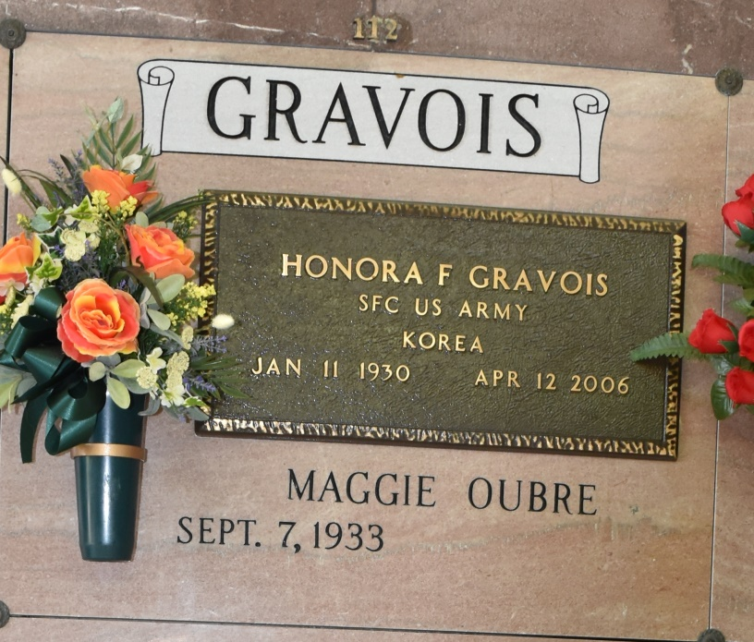

Honora F. Gravois entered eternal life on Wednesday, April 12, 2006 at his home in Vacherie, LA at the age of 76. He is survived by his wife of 53 years, Maggie Oubre Gravois; children: Becky and Glenn Gravois, Jake Gravois and fiancee Rachel Bourg, Blaise and Pat Gravois, Grant and Bonnie Gravois, Anna and John Michelli and Nora and Barry Reulet; 15 grandchildren, 5 great-grandchildren, and brother Elic Gravois. He was preceded in death by his parents Servais (Jake) and Maria Falgoust Gravois, and siblings Albert, Thomas and Stephen Gravois and Anne Becnel, daughter-in-law Judy Gravois, and grandchildren Jamie Gravois and Charisse Gravois. Honora was the retired owner of M & H Builders, Jake Gravois Memorial Park, and co-owner of Gravois Supermarket. He was a veteran of the Korean War, former commander of the American Logion #268, a member of VFW #4245 and Knights of Columbus #11857. He was a former commissioner of the Port of South Louisiana and Board Member of First American Bank and Trust. As an avid sports fan, Honora also served as a member of the Tulane Athletic Club, ASA Softball Commissioner, and President of the Sugar Cane Baseball League. Visitation will commence Sunday, April 16, 2006 from 6:00 p.m. until 9:00 p.m. at Our Lady of Peace Catholic Church Community Center, Vacherie, LA. Visitation will be held Monday, April 17th, 2006 at Our Lady of Peace Catholic Church from 8:00 a.m. until Mass of Christian Burial at 11:00 a.m. Father Michel Miceli - officiating. Entombment will follow in the Church Mausoleum. In lieu of flowers, donations to the following are appreciated: Our Lady of Peace Catholic Church at 13281 Hwy. 644, Vachiere, LA 70090 and Hospice of South Louisiana at 6500 Main St., Houma, LA 70360. OURSO FUNERAL HOME, Donaldsonville, LA entrusted with arrangements.

Times-Picayune, The (New Orleans, LA) - Monday, April 17, 2006  
Contributed by Jane Edson