Luann (Tabor) Gravois

December 11, 1954 – September 20, 2008

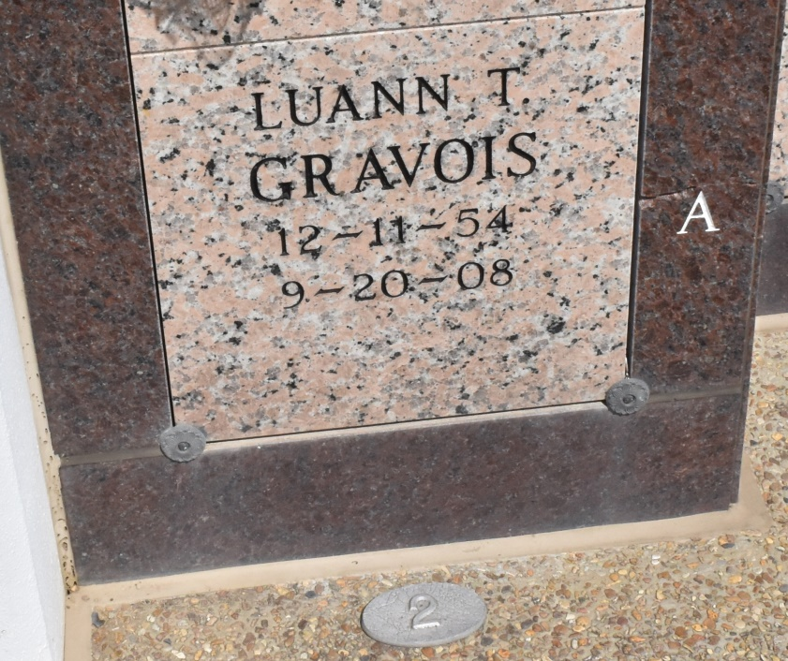

Luann Tabor Gravois, 53, a native and resident of Thibodaux, died at 6:10 p.m. Saturday, Sept. 20, 2008.

Visitation will be from 10 a.m. to funeral time Thursday at St. John the Evangelist Catholic Church in Thibodaux. Mass will be at 11 a.m. Thursday at the church.

She is survived by one son, Robert Gravois III; two daughters, Nili Rougee and husband, Randall, and Shea Gravois; and one sister, Sandy Tabor.

She was preceded in death by her parents, Louis Tabor and Gloria Reynolds Tabor.

Thibodaux Funeral Home is in charge of arrangements.

Houmatoday.com

September 24, 2008