Mary Helen (Bye) Gravois

December 13, 1940 – May 14, 2020

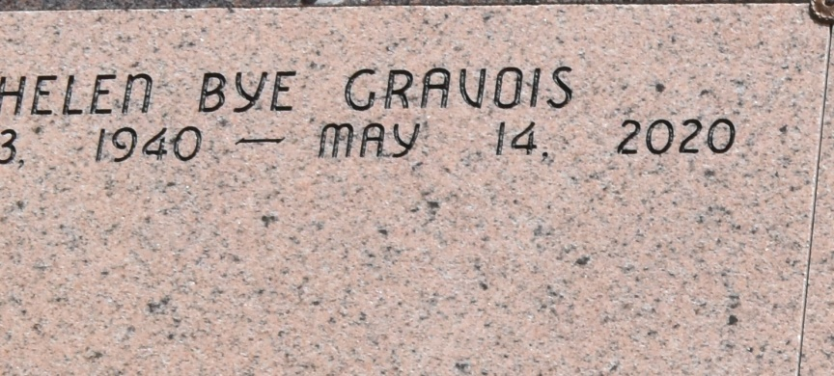

Mary "Helen" Bye Gravois, age 79, beloved mother, grandmother, and great-grandmother, passed away in her home in Vacherie, LA, on May 14, 2020, at 12:45 AM. A Private Visitation and Service by invitation only will be held at Thibodaux Funeral Home and St. Joseph Co-Cathedral in Thibodaux, LA, respectively. In response to the COVID-19 pandemic, the diocese requires that everyone attending the Mass of Christian Burial wear masks and practice social distancing for the duration of their time inside the church.

She is survived by her beloved husband of 61 years, Elic Gravois; son, Eric Gravois and wife Nanci Suski; three daughters, Sandra and husband John Caire, Angie and husband John Torregrossa, Cindy and husband Guy Chauvin; brother, Johny Bye and his wife Darlene; and her 18 grandchildren, Daniel Gravois (Amy), Dakota Gravois (Erin), Seth Gravois, Ashley Prejean (Beau), Michelle Settoon (Scott Jr.), Michael Caire (fiancé Haley Harrington), Stephanie Gaffney (Christopher), Nicole Torregrossa, Alison Summers (Jonathan), Maria Weaver (Richard IV), Joseph Torregrossa, Anthony Torregrossa, Zachary Torregrossa, Joshua Chauvin (Seleste), Benjamin Chauvin (Chandler), Hannah Smith (Nicolas), David Chauvin and John Paul Chauvin; and 13 great-grandchildren, Dawsyn Gravois, Tate Gravois, Riley Prejean, Peyton Prejean, Ambre Settoon, Audrina Settoon, Madeline Gaffney, Baby Gaffney, Baby Weaver (Richard V) Caleb Chauvin, Emmett Chauvin, Jude Chauvin, and Ava Chauvin. She is preceded in death by her parents, Leonce Bye and Elda Bye Breaux; her three sisters, Doris Clay, Molly Kippers, and Elda Bye; brothers-in-law, Kip Kippers and Bill Clay.

The third of five children, Helen was born in St. John the Baptist parish on Golden Star Plantation in Vacherie, LA, on December 13, 1940 to Leonce and Elda Bye. She graduated from St. Joseph Academy Catholic High School in New Orleans, where she played volleyball and basketball, and later in her young adult life, she became an avid tennis player. Helen was a zealous apostle of Christ, who dedicated herself to Christ through the service of the Catholic Church at Our Lady of Peace parish, serving as sacristan, lector, Eucharistic minister, adoration chapel coordinator, and traveling chalice coordinator. She served in various leadership roles in Court Notre Dame de la Paix of the Catholic Daughters for over 30 years, including secretary, treasurer, Regent and District Deputy. For many years, she coordinated the Heart Fund drive for the American Heart Association. Helen lived a sacramental life. She loved deeply and served selflessly as matriarch of her family and servant in her community. We will miss her presence here yet rejoice with her as she enters her heavenly home. Thibodaux Funeral Home in Thibodaux, LA, is in charge of arrangements.

The Advocate, Baton Rouge, LA

May 15 to May 18, 2020