Philip Augustin Gravois

September 1, 1932 – November 23, 2002

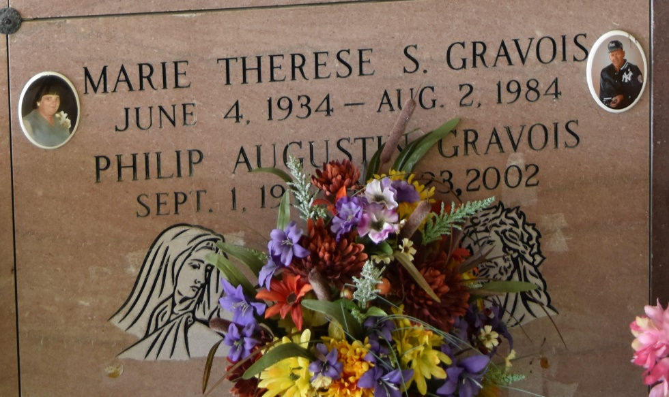

Philip "T.Boy" Gravois, age 70, born September 1, 1932 died November 23, 2002. A native and resident of Vacherie, LA. Survived by his wife, Anna Belle F. Gravois; sons, Dean Gravois and David J. Gravois; daughters, Belinda G. Marse, Marcia G. Martin, Terry G. Amedee; brothers, Francis, Edwin and Allen Gravois; sisters, Lydia G. Labat, Virginia G. Lachie, Anne G. Granier; 10 grandchildren and 8 great-grandchildren. Preceded in death by first wife, Therese Stein Gravois and parents, Felix Gravois and Effie Steib Gravois; brother, Raymond Gravois and sister, Mildred (Millie) Webre. Visitation 6 PM until 9 PM Monday, November 25, 2002 and 7 AM until funeral time Tuesday, November 26, 2002 at Our Lady of Peace Catholic Church. Mass of Christian Burial Tuesday, November 26, 2002 at 10:30 at Our Lady of Peace Catholic Church. Interment in Our Lady of Peace Catholic Church Cemetery. THIBODAUX FUNERAL HOME, INC., THIBODAUX, LA IN CHARGE OF ARRANGEMENTS.

Times-Picayune, The (New Orleans, LA)

Monday, November 25, 2002  
Contributed by Jane Edson