Stella May (Granier) Gravois

December 22, 1913 – April 29, 2007

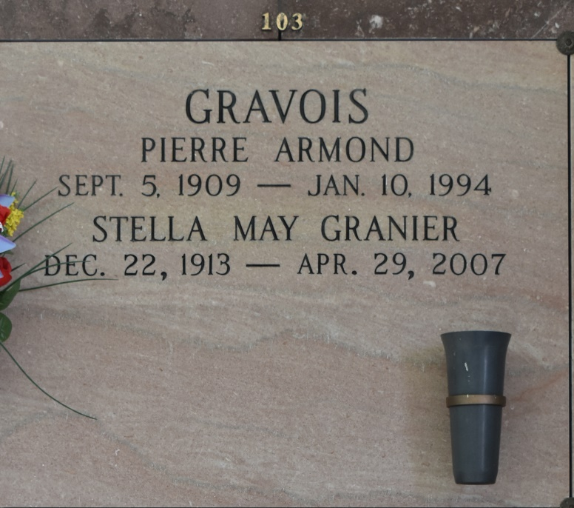

Stella Granier Gravois, a retired teacher in the St. James Parish school system with 34 years of service and a resident of Vacherie, died Sunday, April 29, 2007, at 7:15 p.m. She was 93, born Dec. 22, 1913, in St. James. Visiting at Our Lady of Peace Catholic Church, Vacherie, on Thursday, May 3, from 8 a.m. until Mass of Christian Burial at 11 a.m. Interment in the church cemetery. Survived by her daughters and sons-in-law, Mary G. and Daniel Mowrey and Joyce Anne G. and Kenneth Bakke; brother, Luke "Duck" Granier; and four grandchildren. Preceded in death by her husband, Pierre Gravois; parents, Luke Granier Sr. and Mary Elizabeth Thibodeaux Granier; brothers, Louis, Charles, Joseph, John and James Granier; and sisters, Sister Mary Felicitas Granier, Evelyn Comeau and Edith Shaheen. Landry's Funeral Home, Thibodeaux, is in charge of arrangements.

The Advocate, Baton Rouge, Louisiana

May 2, 2007