Brianne Antoinette Gros

October 20, 1988 – December 29, 2008

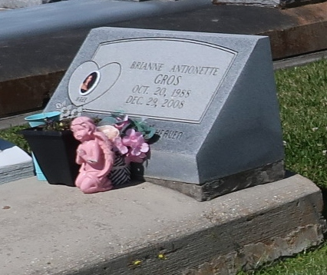

Brianne A. Gros, of Vacherie, La. on Mon. Dec. 29, 2008 departed this life. Age 20 yrs. Daughter of Thaddeus and Wilma Cruz Gros. Mother of Thayden Paul Gros. Sister of Thaddeus Jr. and the late Brandon Gros. Granddaughter of Floyd Cruz and the late Joan Wooden, and the late Edmond and Francine Gros. Also survived by aunts, uncles, cousins, other relatives and friends. Companion of Shane Zenon. Relatives and friends of the family, also pastor, officers, and members, of the Greater Woodville B.C. and neighboring churches, employees of Domino Pizza-Thibodaux, Dow-St. Charles Operations, Nicholls State Univ., and St. James High School Class of 07, are invited to attend the funeral services on Sat. Jan. 3, 2009 at 12:00 noon from the Greater Woodville B.C. 133 West 9th St., Wallace, La., Rev. Mark Nelson officating. Interment Our Lady of Peace Catholic Church Cemetery, Vacherie, La. Visitation at the church after 9:30 am. Final viewing before service. The Baloney Funeral Home LLC 399 Earl Baloney Dr. Garyville, La. 70051 985-535-2540 In Charge of Arrangements.

The Times-Picayune, New Orleans, LA

January 2, 2009