Ernest Joseph Harry

October 24, 1924 – April 18, 1999

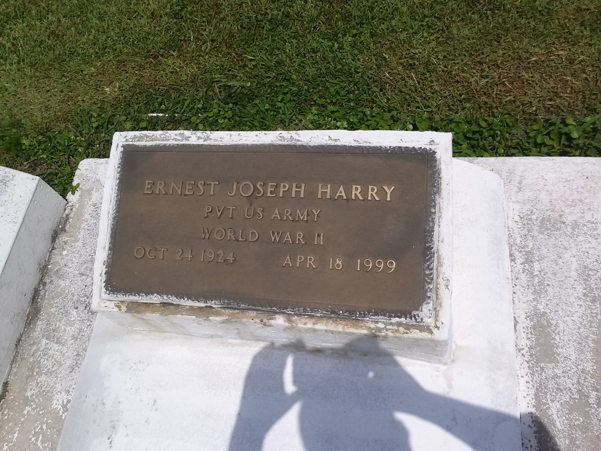

Photo by TMB

Ernest Joseph "Babe Ruth" Harry, 75, a native and resident of Vacherie, died April 18, 1999. He was the husband of the late Rose Mary Jessie Harry,Joyce Saul and Lillie Mae VanBuren. He was the father of Raymond, Elston,Stephen, Paul, Clarence, Eddie and Maude Harry, Catherine Lacey, Leslie Keller and Kathleen Rodrigue.

He was the son of the late Bienvenue an Mary Keller Harry and the brother of Amie Chopin, Esther Williams, Eve and Anita Batiste, Milton, Silvain and Herbert Harry and the late Jules Sr., Alfred and Raymond Harry. He is survived by 16 grandchildren, six great-grandchildren.

Unknown source