Joseph Earlis Harry Sr.

April 7, 1943 – July 12, 2010

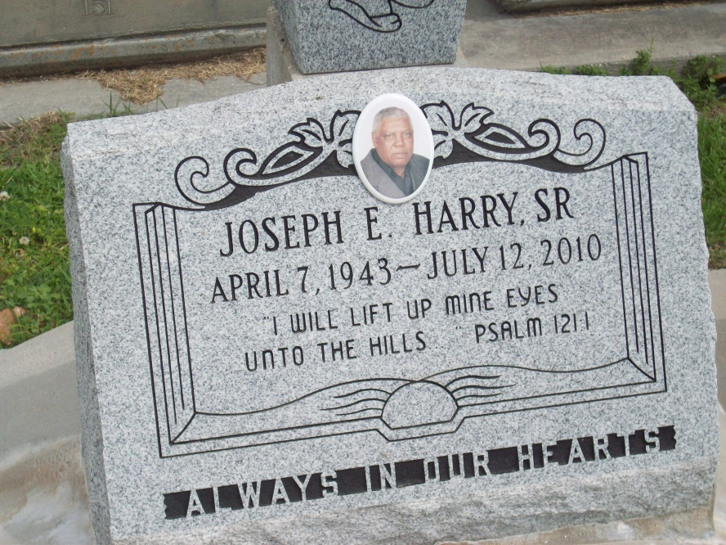

Photo by TMB

Joseph Earlis Harry, 67, of Vacherie, died Monday, July 12, 2010, at home surrounded by his family. Family and friends are invited to attend the visitation from 9 a.m. to service time Saturday at Our Lady of Peace Catholic Church, 13281 La. 644 in Vacherie. Mass will be held at 11 a.m. Saturday at the church. He is survived by his wife, Audrey M. Joseph; four daughters, Pamela and husband, Paul Keller, Penelope and husband, Bryant Gilton, Akisha and husband, Troy Batiste, Racquel and husband, Shannon Jones Sr.; two sons, Rydell and wife, Sauhha Harry, and Jeremy and wife, Denisha Harry; and six siblings, Robert Harry, Mary Jessie, Phyllis Richard, Lionel, Whitney, and Cassandra M. Harry. He was preceded in death by two sons, Joseph Earlis Jr. and Jermaine; his parents, Silvain and Lucille Harry; one sister, Theresa Bartholomew; and his grandparents, Mary and Bievenue Harry, and Mary and Lionel Dumas. He was a parishioner of Our Lady of Peace Catholic Church in Vacherie. He was employed by Northrop Grumman, formerly named Avondale Shipyard.

Unknown source