Marie Elizabeth (Dumas) Harry

April 14, 1924 – November 13, 2003

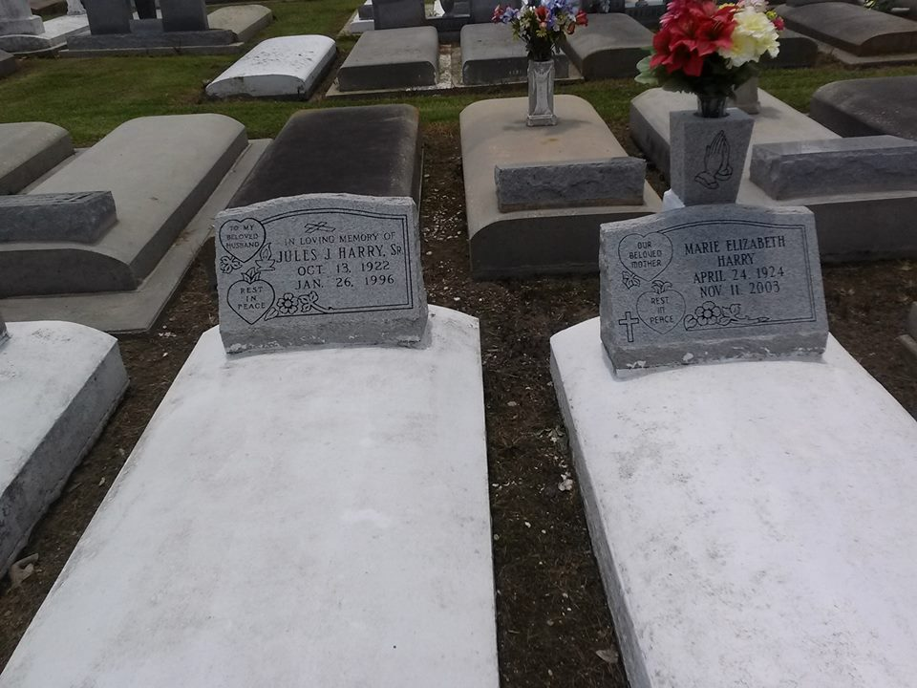

Photo by TMB

Marie Elizabeth (T-Zob) Dumas Harry, of Vacherie, La. on Tuesday, November 11, 2003. Wife of the late Jules J. Harry Sr. Mother of Joseph Jr., Jerry, Grace, Donald Sr., Lester Harry and Christine Riley all of Vacherie, La., Ronald Harry, Sr. of Thibodaux, La., Brian Harry of LaPlace, La. and the late Timothy and Barbara Harry. Sister of Lucille Riley, Gladys D. Trepagnier, Paul Dumas of New Orleans, La. and the late Elizy, Victor, Easton, Herman Dumas, Grace Gros and Margaret Robinson. Also survived by (20) grandchildren (28) great grandchildren, sons and daughters-in-law, sisters and brothers-in-law, nieces, nephews, cousins and friends. A native and resident of Vacherie, La. Age 79 years.

Unknown source