Milton Joseph Harry Sr.

March 7th, 1929 - March 2nd, 2019

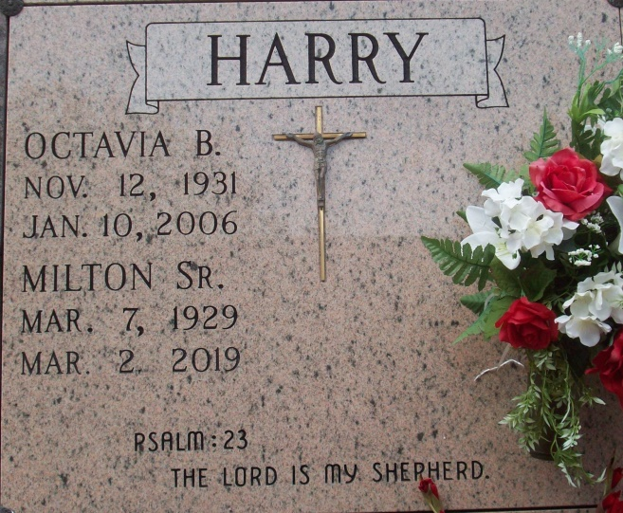

Photo by TMB

“With long life I will satisfy him and show him my salvation.” Psalm 91:16

Milton Joseph Harry, Sr., a native and resident of Vacherie, Louisiana, peacefully passed away Saturday, March 2, 2019, surrounded by family members. He was 89. Milton, also known as “Black” or “Shade”, was born March 7, 1929 to Bievenue and Mary Keller Harry. He is the brother of Amie Chopin, Raymond, Silvain, Jules, Sr., Ernest, Alfred, Herbert Sr., Eva and Anita Batiste and Esther Williams. He was the loving husband of the late Octavia Batiste and together they had ten children. Milton was a lifelong member of Our Lady of Peace Catholic Church where he once served as an usher. He was also a member of the Good Children Benevolent Society. He valued work and became a construction worker. He labored at Peevy Grain Elevator, worked 32 years at Johns Manville and several years at Brice Building Company. After retiring in 1991, he got involved in cement finishing, raising pigs and growing a vegetable garden. Milton was a well-mannered man who loved life. He enjoyed his family and friends because they were important to him. He enjoyed social gatherings and dancing. He enjoyed sports, particularly baseball and football. He was proud to be a player on the first colored baseball team in Vacherie. For many years he was a Dodgers baseball fan and a committed follower of the New Orleans Saints football team. Milton is survived by nine children: Rita (Nelson) Steib, Milton (Grace), Jr., Martin, Sr., Doris (Paul) Narcisse, Michael Sr., Andy (Stephanie) Sr., Antoine (April), Deborah and Sandy Harry.; 41 grandchildren, 81 great-grandchildren, 11 great-great grandchildren, two sisters Eva Batiste and Anita Batiste and a host of nieces, nephews and friends. Milton was preceded in death by his wife Octavia, son Randy, grandson Dale DJ Gordon, grand-daughter Angel Gordon, great grandson Courtland Long; Parents Bievenue and Mary Keller Harry; Siblings -Amie Chopin, Raymond, Silvain, Jules, Sr., Ernest, Alfred, Herbert Sr., and Esther Williams. There will be a mass of christian burial on Saturday, March 9, 2019 at 10:00am from Our Lady of Peace Catholic Church, 13281 Highway 644, Vacherie, LA. Father Matthew McCaughey-Celebrant. Visitation from 8:00am until service time.

Unknown source