Octavia (Baptiste) Harry

November 12, 1931 – January 10, 2006

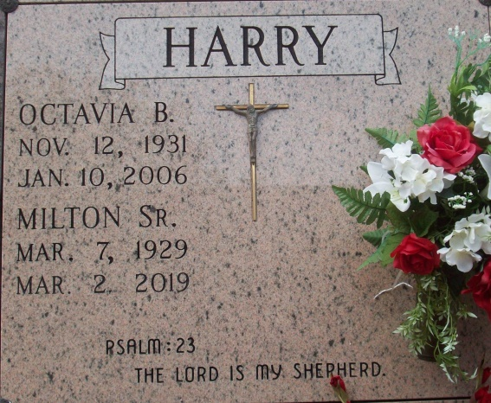

Photo by TMB

Octavia B. Harry, a homemaker, died peacefully on Tuesday, Jan. 10, 2006, at her home. She was 74. She was a lifelong resident of Vacherie and a devoted Christian. She was a member of Good Children Society and Our Lady Of Peace Catholic Church. Survivors include her husband of 57 years, Milton Harry Sr.; nine children, Rita H. Steib and husband Nelson, Milton Jr. and wife Grace, Martin Harry Sr., Doris H. Narcisse and husband Paul, Michael Sr., Deborah Harry, Andy Harry Sr. and Sandra H. Ricks and husband Albert, all of Vacherie, and Antoine Harry and wife Cynthia of Thibodaux; five brothers, Davis and wife Eva, August and wife Lois, Claude Sr. and wife Patricia, Wallace Sr. and wife Carmen Batiste, all of Vacherie, and Sylvester and wife Veronica Batiste of Mississippi; two sisters, Mary B. Bovie of Vacherie and Mary B. Jenkins and husband Nathaniel of Chandler, Ind.; an uncle, Simeon Laurent of Vacherie; and 44 grandchildren, 29 great-grandchildren, a faithful and true friend, Dora Oubre Saul; seven godchildren and a host of nieces, nephews, cousins and friends. She was preceded in death by her son, Randy Harry; parents, Claudia and Antoine Batiste; brothers, Raymond and Sidney Batiste; two sisters-in-law, Beatrice and Marie Batiste; and a brother-in-law, Charles Bovie. A Mass of Christian Burial will be held at Our Lady of Peace Catholic Church, 13281 La. 644, Vacherie, on Saturday, Jan. 14, at noon. Visitation at the church from 9 a.m. until service time. Entombment in the church mausoleum. Arrangements by Rhodes United Fidelity Funeral Home, 2929 Scenic Highway.

Advocate, The (Baton Rouge, LA) - Saturday, January 14, 2006

Contributed by Jane Edson