Randy Matthew Harry

February 8, 1962 – September 21, 2004

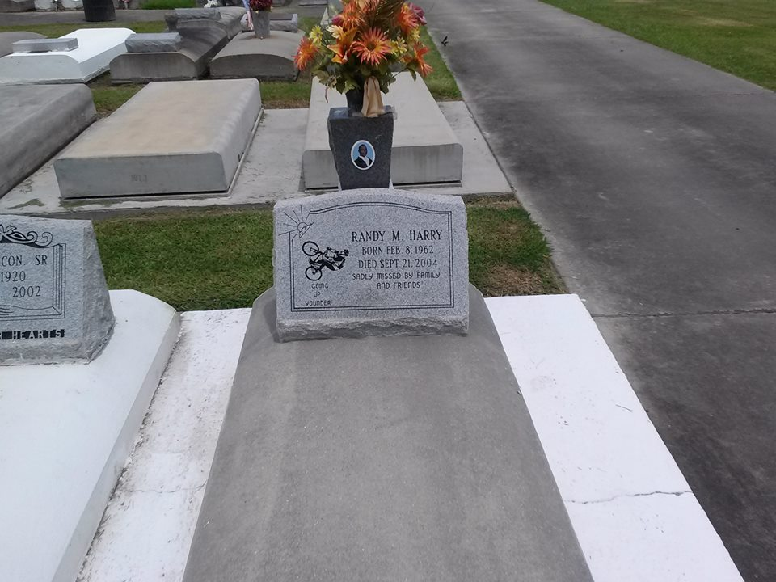

Photo by TMB

Randy Matthew Harry, a laborer, died Sept 21, 2004 at Charity Hospital of injuries suffered in a hit-and-run accident. He was 42. Mr. Harry was a lifelong resident of Vacherie. He was a member of Good Children Society. Survivors include four daughters, Kita and Kionne Harry, Nadia Porche and LaKrisha Dumas; five brothers, Milton Harry Jr., Martin Harry Sr., Michael Harry Sr., Andy Harry Sr. and Antoine Harry; four sisters, Rita Steib, Doris Narcisse, Deborah Harry and Sandra Ricks; his parents, Octavia Batiste and Milton Harry Sr.; and two grandchildren.

Unknown source