Silvain Harry

April 13, 1920 – August 2, 1999

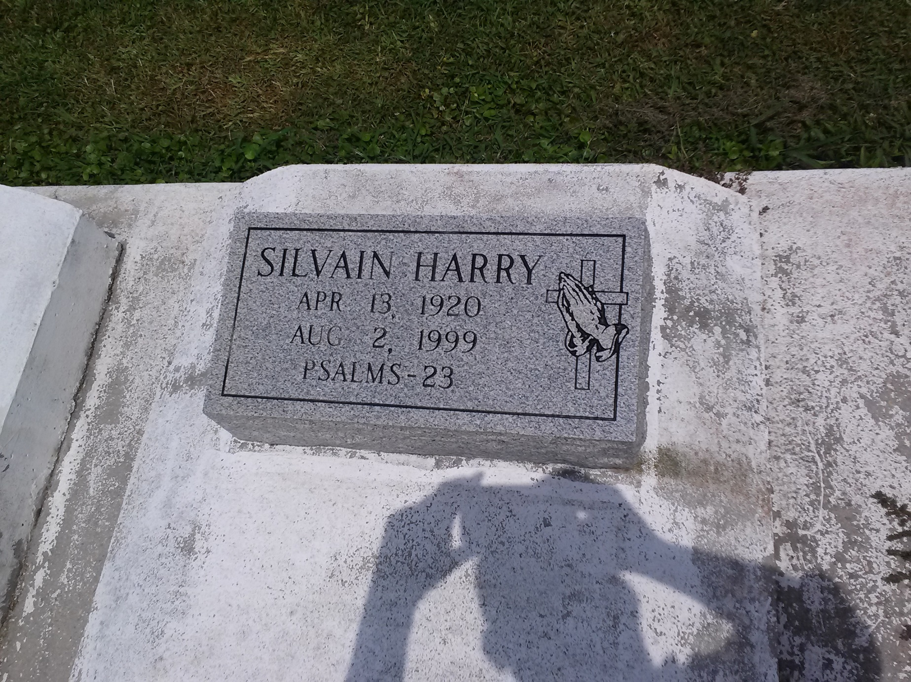

Photo by TMB

Silvan "Russel" Harry, a retired carpenter, died Monday August 2, 1999 at Thibodeaux Regional Medical Center. He was 79. Mr. Harry was a lifelong resident of Vacherie. He was a parishioner of Our Lady of Peace Catholic Church and The Good Children Society. Survivors include four sons, Joseph E., Robert, Lionel and Whitney Harry; four daughters, Theresa Bartholomew, Mary E. Jessie, Phyllis and Cassandra Harry; two brothers, Milton Sr. and Herbert Harry Sr.; four sisters, Amie Chopin and Esther Williams, both of Marrero, and Eva and Anita Batiste; 26 grandchildren; and 21 great-grandchildren.

Unknown source