Dewey Holmes

August 13, 1936 – February 13, 2006

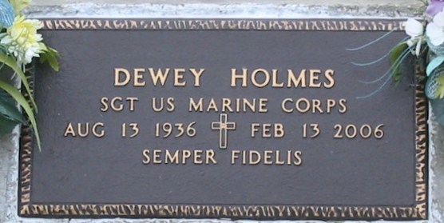

Photo by Bobby

VACHERIE - Dewey Holmes, 69, a native of Camargo, Oklahoma and a resident of Vacherie, died Feb. 13.  
  
He was the husband of Cheryl Brazan Holmes.  
  
He is survived by his children Bryan Keith Holmes and Denise Marie Doutt.  
  
He is also survived by five grandchildren.  
  
He was preceded in death by his parents Dale and Marie Fulton Holmes, a son Scott Holmes and a sister Anna Juanita Holmes.  
  
Services will be held today at 1 p.m. at Episcopal Church at Victory Assembly of God, Vacherie.  
  
Rose Lynn Funeral Services is in charge of arrangements. Visitation begins at noon at the church.

L'Observateur (La Place, LA) - Tuesday, February 21, 2006

Contributed by Jane Edson