Ethel (Domino) Holmes

December 5, 1917 – July 17, 1997

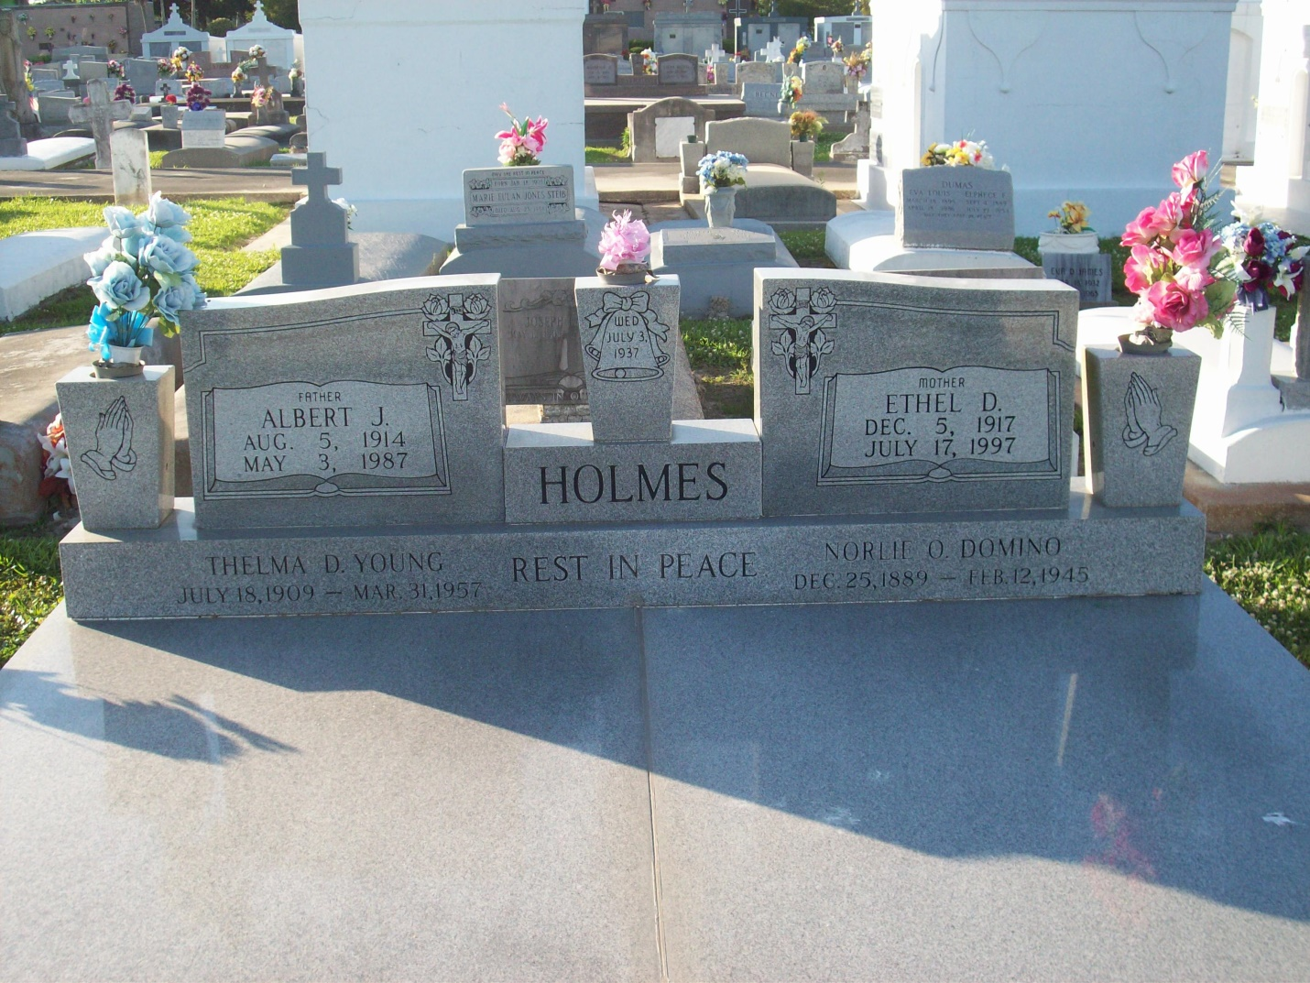

Ethel Domino Holmes, a homemaker, died Thursday July 17,1997 at West Jefferson Medical Center. She was 79. Mrs. Holmes was born in Vacherie and lived in Marrero for more than 50 years. She was a parishioner of St. Joseph the Worker Catholic Church. Survivors include a daughter, Leona Domino Marshall; two brothers, Wilfred Domino of Los Angeles and Hilton Domino; a sister, Alma Triche of Ama; and two grandchildren.

Unknown source