Oregan Howard, Sr.

March 22, 1926 – August 6, 2009

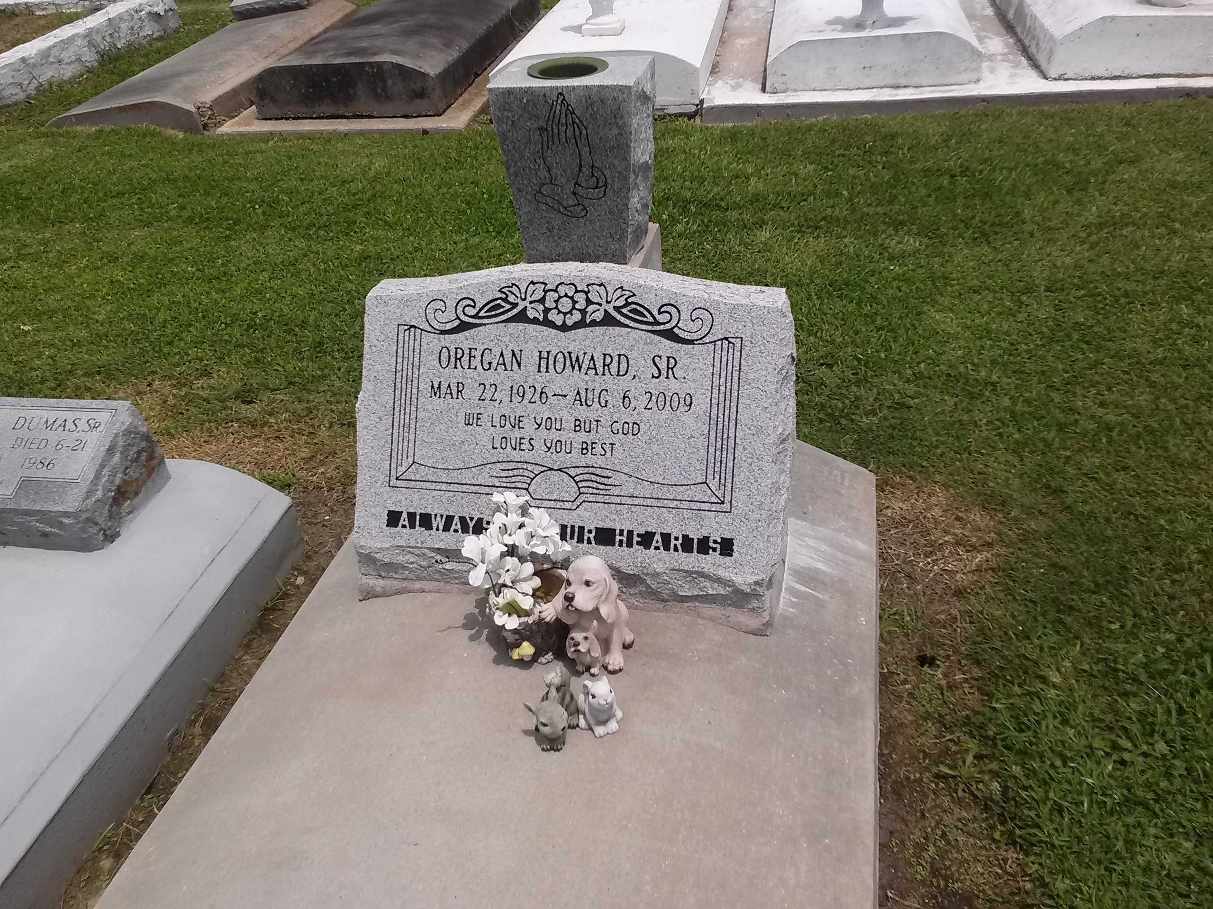

Photo by TMB

Oregan “Lil Buddy” Howard, Sr., age 83, on Thursday, August 6, 2009, a retired employee of Johns Mansville for thirty years, beloved husband of Ethel Isom Howard, father of James Howard, Lawrence Howard, Arnold (Melinda) Howard, Rodney (Tammy) Howard, Kevin (Sonya) Howard, Valerie (James) Favorite, Isabelle (James) Narcisse, Phyllis (Victor) Nicholas, and Verilyn (Barry) Melancon; brother of Dorothy H. Batiste, brother-in-law of Lottie (Peter) Mitchell, Sr., Josephine Kennedy, Joseph Isom, and Evelyn Isom; and former son-in-law Alvin Conerly, Sr.; and a devoted friend David Stewart. Also survived by 28 grandchildren, 35 great grandchildren, and a host of nieces, nephews, other relatives and friends. A native of Vacherie, LA and a resident of Marrero, LA for over fifty years. He was preceded in death by his parents; Earnest Sr. and Nettie Lewis Howard; three siblings Percy Howard, Sr., Ruth H. Harris, Rev. Ernest Howard, Jr.; two sons Oregan Howard, Jr., and Dennis Howard; father and mother-in-law, John Sr. and Laura James Isom; two grandchildren Jeanette Conerly and Chase Favorite; daughter-in-law Sandra W. Howard; brother-in laws John Isom, Jr., Willie Isom, Norris Isom, Robert Harris, Nelson Batiste, Paul Steib, and Barry Kennedy; sister-in laws Ruby Z. Howard and Josephine S. Isom; and a devoted friend Harry Sorrell.

Unknown source