Daniel J. Hymel

July 26, 1958 – March 15, 2020

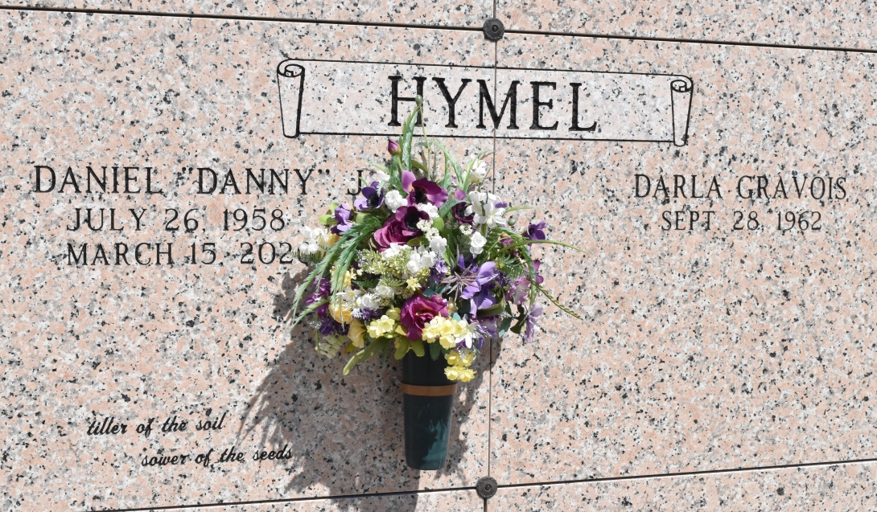

Daniel "Danny" J. Hymel, 61, of Vacherie, passed away at his home on March 15, 2020, surrounded by his loving family and close friends. Danny was a 3rd generation sugarcane farmer and co-owner of M. Hymel Sons Inc.   
Private services only.  
 He is survived by his wife, Darla G. Hymel; sons, Lance Hymel, Layne Hymel; brother, Edward "Eddie" Hymel and wife, Patti; sisters, Mary Lynne Chabaud and husband, Gene, Susan Condon and husband, Richard, and Danielle Dubreuil and husband, Brian; godchildren, Stephanie Hymel, Therese Hymel and Alise C. Hagan; and numerous nieces and nephews.  
 He was preceded in death by his parents, Lynn G. Hymel and Barbara "Gayle" Gendron Hymel; and infant brother, Gerard Hymel.  
 In lieu of flowers, donations can be made by selecting Gayle and Tom Benson Cancer Center at [Giving.Ochsner.org](http://giving.ochsner.org/). Thibodaux Funeral Home is in charge of arrangements.

Houma Today, Terrebonne Parish, Louisiana

Mar. 16 to Mar. 17, 2020