Eddie Joseph Hymel

March 15, 1933 – August 16, 2020

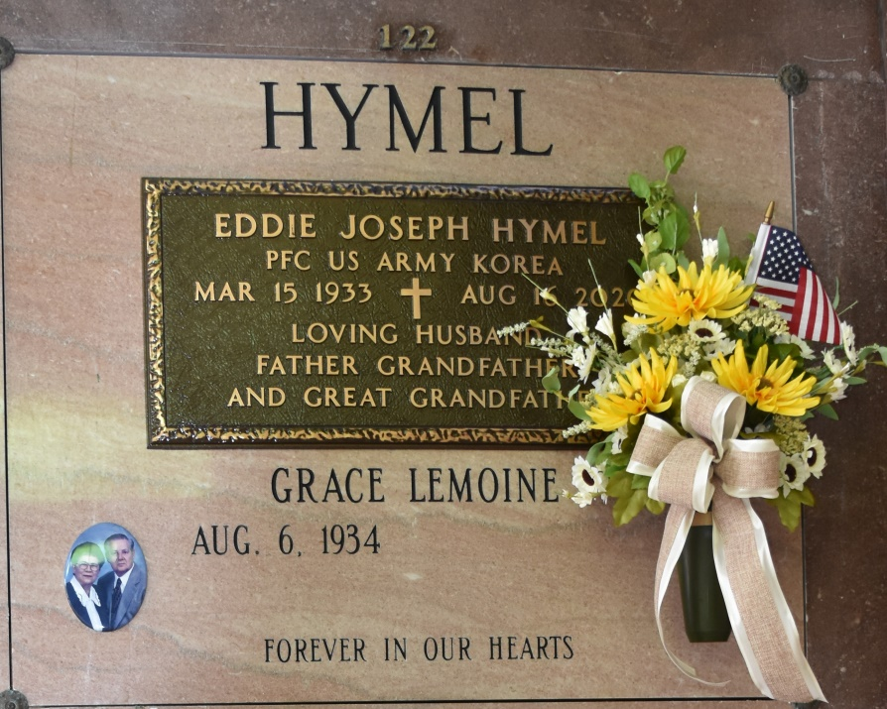

Eddie “Boobie” Hymel, a native of St. James and a resident of Vacherie, passed away peacefully at his home on Sunday, August 16, 2020 at the age of 87.

Eddie proudly served his country in the US Army during the Korean War.  He retired from Kaiser Aluminum after 38 years as a heavy equipment operator. His greatest joy was gathering with his family on Sundays.  He will be greatly missed by everyone who knew him.

He is survived by his loving wife of 64 years, Grace L. Hymel; children, Brenda Gravois (Alan), Janel Berger (Don), Danny Hymel (Snoopy) and Chad Hymel (April); 8 grandchildren, Brad Gravois (Tiffany), Ryan Gravois (Elaine), Casey Ledet, Nick Berger (Amanda), Aaron Hymel (Sydney), Cody, Riley and Ellie Hymel; 7 great-grandchildren, Hannah, Hali and Parker Gravois, Christopher and William Gravois and Grayson and Emersyn Berger; sisters, Audrey Becnel (James), Carlyn Kliebert (A.J.), Sylvia Bourgeois (Jack), Janet Ponson (Carroll Sr.) and Jane Rivere; and sisters-in-law, Teen Hymel and Janice Hymel.

He is preceded in death by his daughter, Sharon Ledet; parents, Jules and Lucella Hymel; and brothers, Kelsey, Warren and Herman “T-Boy” Hymel.

Due to the current circumstances, a private visitation and mass will be held for his family.  In lieu of flowers, donations can be made to St. James Arc. Rose Lynn Funeral Services has been entrusted with handling his arrangements.

Rose Lynn Funeral Home, Lutcher, LA