Kelsey Pierre Hymel

December 4, 1931 – January 7, 2013

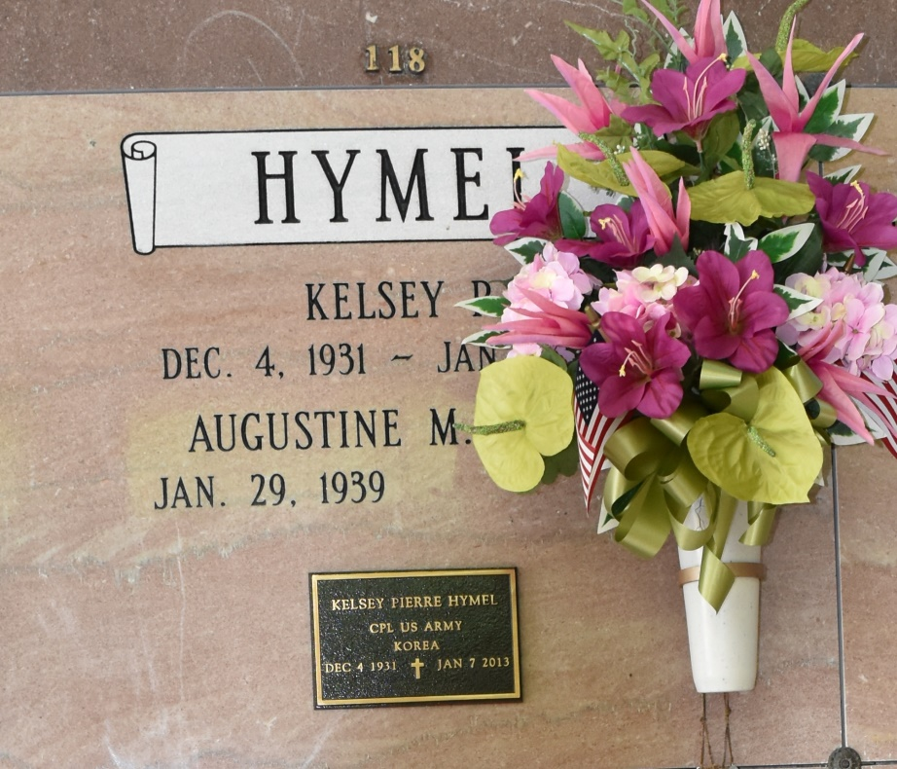

Kelsey P. Hymel was born in St. James, LA on December 4, 1931 and passed away at home in Vacherie, LA on January 7, 2013 at 6:40 a.m. He was the loving husband of Augustine Marse Hymel for 57 years. He was a member of KC Council 1514, a Korean War Veteran, and a retiree from Monsanto after 30 years. In lieu of flowers, the family requests donations in his memory to The National Shrine of Blessed Francis Seelos, 919 Josephine St., New Orleans, LA or St. Joseph Hospice, Bayou Region, 103 Ridgefield Rd., Thibodaux, LA 70301. Survived By Geralyn H. Becnel (Husband Bryon), Daughter; Connie H. Morvant (husband Benton), Daughter; Heidi B. Martinez (husband Robby); Grandchild Shawn Becnel (fianceeŒ Nicole Poche); Grandchild Robert Morvant; Grandchild; Allie Martinez, Great-granddaughter; Claire Gauthreaux, Janice Hymel, and Doon Marse, Sisters-in-law; Eddie J. Hymel (wife Grace), and Herman J. Hymel, Brothers; Audrey H. Becnel (husband Jimmie), Sister; Carlyn H. Kliebert (husband A.J.), Sister; Sylvia H. Bourgeois (husband Lionel), Sister; Janet H. Ponson (husband Carroll), Sister; Jane H. Rivere, Sister. Preceded in Death By Jules and Lucella Loup Hymel, Parents; Warren P. Hymel, Brother.

Unknown source