Harold Isom Sr.

October 18, 1945 – November 23, 2014

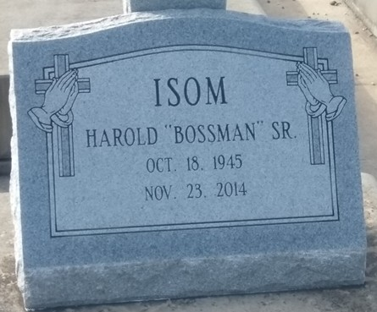

Photo by TMB

Harold Isom Sr. at the age of 69 years departed this earthly life on Sunday, November 23, 2014 at Chateau Terrebonne Health Care in Houma, LA. Son of the late Ethel C. and Murphy P. Isom Sr. Loving father of Angela I. Cruz (Cesar), Harold Isom Jr., and Yule D. Cooper. Brother of Lillie I. Hollins, Theresia I. Devare, Ethel I. Champagne, Irma I. Melancon, Juanita I. Lee (Gaston), Elaine I. Sterling, Eva Lois, Mary, Murphy P. Jr. (Sheral), Wallace (Kathleen), Herman and Alex Isom and the late Vernita Anderson, and Edison and Willie Isom. Grandfather of Danisha K. Davis and Shayla A. Cruz. Great grandfather of Darrell and A'Zyren Stevens.

Unknown source