Joseph Henry Isom Jr.

April 29, 1951 – June 1, 1994

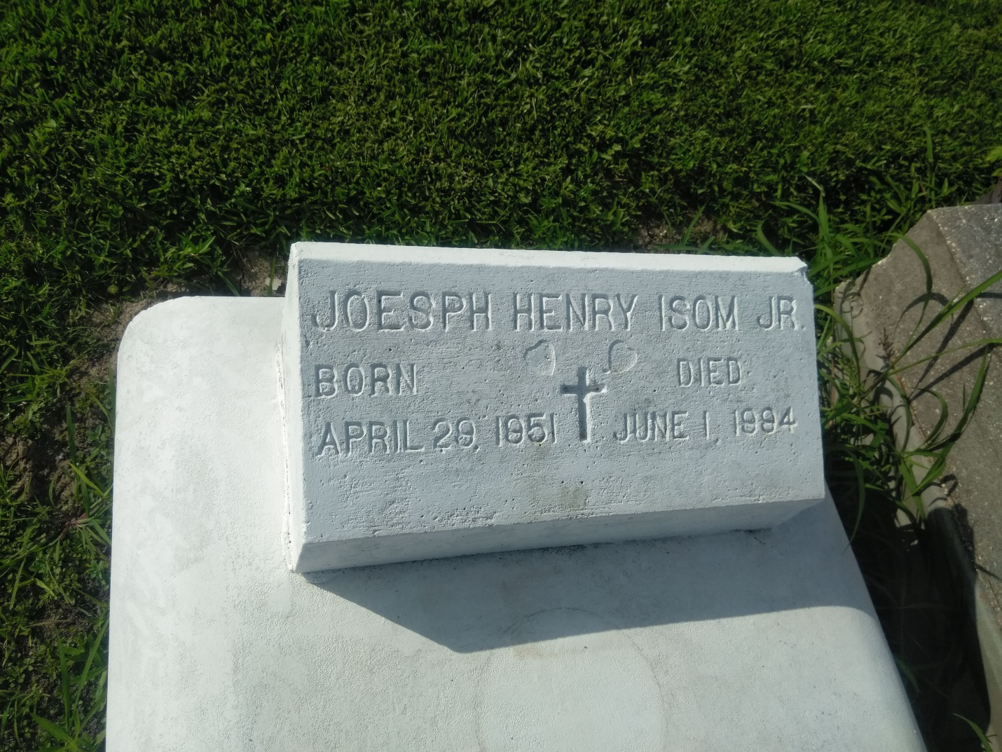

Photo by TMB

A Mass of Christian burial was celebrated at 11 a.m. today at Our Lady of Peace Catholic Church in Vacherie for Joseph Henry Isom Jr., 43, a native and resident of Vacherie, who died at 12:45 a.m. Wednesday, June 1. Burial was in the church cemetery.

He was the husband of Betty Miller Isom of Vacherie; son of Joseph Henry Isom Sr. of Vacherie; brother of Terry Sr. and Yvonne Isom and Emily I. Steib, all of Vacherie. He was preceded in death by his mother, Mary Wood Isom.

Southall-Westside Funeral Home in Vacherie was in charge of arrangements.

Unknown source