Norris Isom

August 7, 1940 – July 12, 2009

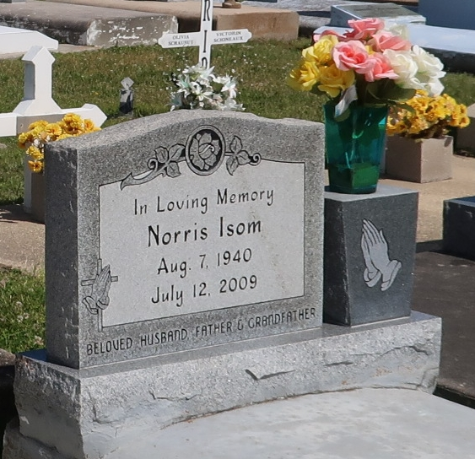

Norris “Ike” Isom, 68, a native and resident of Vacherie, La., died Sunday, July 12.

He is survived by his wife, Evelyn Dabney Isom; one daughter, Desiree Otundo and husband Richard of Vacherie; two sons, Everett Isom of Houston, Texas, and Kendall Isom and wife Pamela of Austin, Texas; one brother Cleveland Isom of Vacherie; three sisters, Ethel and Oregon of Marrero, La., Josephine Kennedy of New Orleans, La., and Lottie Mitchell and husband Peter Sr. of St. James, La.; six grandchildren; and one great-grandchild.

He was preceded in death by his parents, John and Laura Isom; one grandson, Leland Christopher Isom; one sister, Alice I. Steib; and two brothers, John Jr. and Willie Isom.

Mass was Friday, July 17, at Our Lady of Peace Catholic Church with burial at the church cemetery. Williams and Southall Funeral Home is in charge of the arrangements.

Houmatimes.com

July 17, 2009