Louise (Harris) James

1931 – February 13, 2021

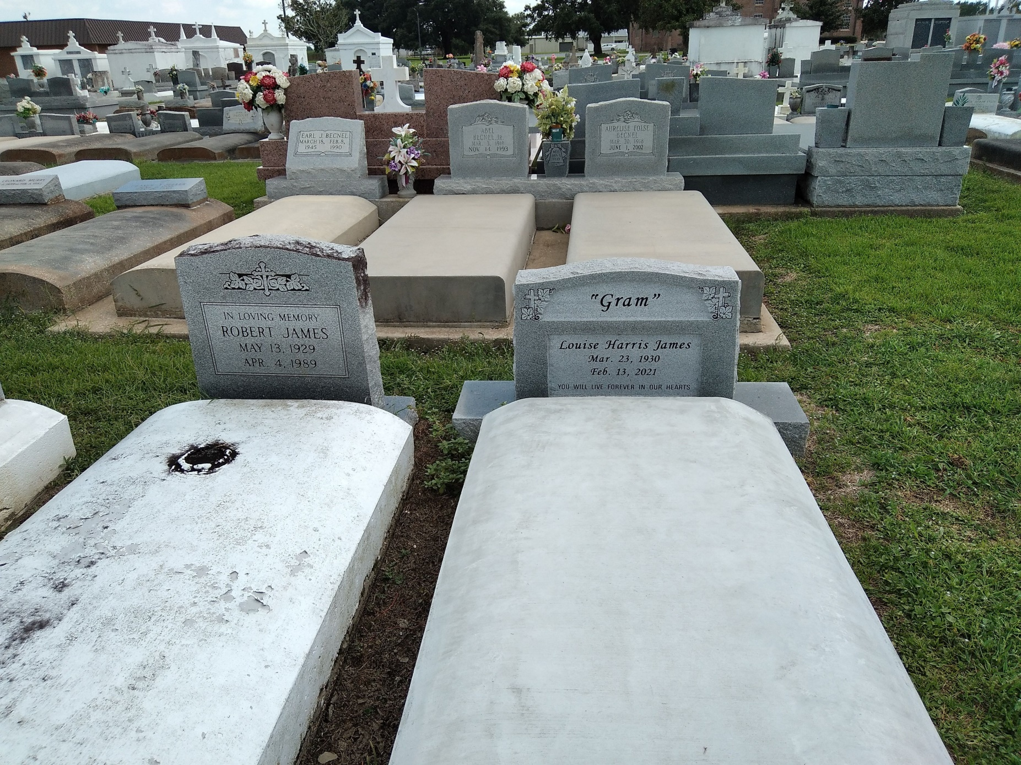

Photo by TMB

Louise Harris James died on Saturday February 13, 2021. She was 90 and a native and resident of Vacherie, LA.

Visitation on Thursday February 18, 2021 at Williams and Southall Funeral Home, 101 Loop 945, Donaldsonville, LA from 3:00 pm to 5:00 pm. Private Mass of Christian Burial on Friday, February 19, 2021 at Our Lady of Peace Catholic Church, Vacherie, LA at 11:00 am. Interment in the church cemetery.

She leaves to cherish her loving memories, daughters, Glenda H. Fletcher, Linda J. Johnson, Lois J. Harris, Vanessa James, Yvette James, Angie J. Broden (Michael); sons, Tyrone James, Rodney Janes, Randy James and Dwayne James (Lovenia).

Preceded in death by her beloved husband Robert James; sons, Junior and Ronald James; parents, Ernest Harris, Jr. and Beatrice D. Harris; sisters, Rosemary Mitt, Shirley H. Ross; brothers, Ulysses and Ernest Harris.

Arrangements by Williams & Southall Funeral Home, 5414 Hwy 1, Napoleonville, LA 70390 (985) 369-7231. To sign guest book or offer condolences, visit our website [www.williamsandsouthallfuneralhome.com.](http://www.williamsandsouthallfuneralhome.com/)

The Advocate, Baton Rouge, LA

Feb. 17 to Feb. 18, 2021