Cynteia Marie (Bethancourt) Jessie

April 4, 1951 - September 23, 2021

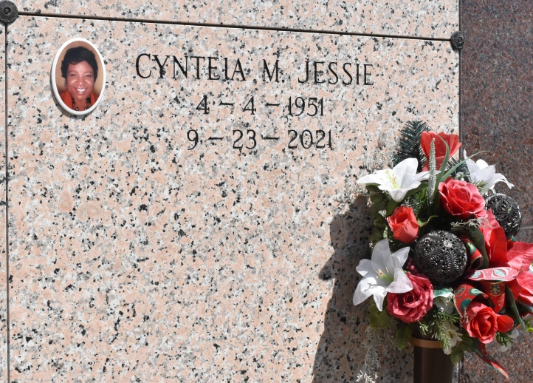

Cynteia was born April 4, 1951, to the late Norman Bethancourt, Sr., and Evelyn Chopin Bethancourt. She was raised by maternal grandparents Maude and Marshall Chopin. She graduated from Second Ward High in 1969, as class Valedictorian. She then attended Southern University, where she received a BS in Mathematics in 1973. She went on to attend Nichols State University, where she received her Master of Education (Admin and Supervision) in 1980. During her second year in college, she married the love of her life, Johnny Jessie.  
 After finishing college, Cynteia was a substitute teacher for a year in St. John the Baptist Parish. She taught at various schools including her old elementary and high schools. The following year, she went to St. Charles Parish, where she taught for thirty-six years. After sitting out a year, she taught at the Alternative School for an additional three years.  
 Cynteia then devoted her time to the teaching and learning of her granddaughters. She was a devoted wife, mother, and grandmother. She loved her granddaughters as much as she loved her sons. She didn’t have any daughters, but regarding these two, Kennedy and Sydney, she would say, “I got my angels.” She was also blessed to have a daughter-in-law, Janelle, whom she adored. Cynteia’s motto was “be kind and loving to anyone you know and meet, because the person you know, or meet might just need to hear a kind word to inspire their life.” She believed that you must live life on day at a time. Cyn was a dedicated teacher who motivated her students to succeed to their fullest potential. She loved family, poetry, Sudoku puzzles, cooking, baking, reading, and making home floor plans.  
 Cynteia leaves to cherish her precious memories, her husband, Johnny Jessie; sons, Dr. Elliot Michael Jessie (Janelle) and Jason Anthony Jessie; her precious granddaughters, Kennedy and Sydney Jessie; her mother, Evelyn Chopin Bathancourt; sisters, Avis (Alvin) Pickens and Renette (Kerry) Lumar; brothers, Norman, Jr., Kelvin, Brian (Sharnicia) and Telly (Nykosha) Bethancourt; step-sisters, Yolanda Isaac and Shirley Davis; step-brother, Joseph Davis; sister-in-law Elnora; brothers-in-law, Elroy, Harold (Evelyn) and Jimmie (Florance) Jessie, and a loving uncle, Lester (Vivian) Chopin. She also leaves a loving extended family of nieces, nephews, cousins, aunts, uncles, and Godchild, Courtney Baloney.  
 She was preceded in death by her maternal grandparents, Maude and Marshall Chopin; paternal grandparents, Evenly and Floriston Bathencourt; sister, Gwindella (Ferman) Joseph; father and mother-in-law, Lloyd and Elodie Steib Jessie; stepbrother, Donald Davis; niece, Tellay’Ja Bethancourt, and a host of aunts, uncles, sisters-in-law and brothers-in-law.  
 A Mass of Christian burial will be held on Thursday, September 30, 2021, at Our Lady of Peace Catholic Church, 13281 LA-644, Vacherie, LA 70090. Visiting period with family will begin at 9am until the start of the service at 11am. Father John Vu officiating. Entombment to follow at Our Lady of Peace Catholic Church Cemetery. Final care and professional services entrusted to Treasures of Life Funeral Services, 315 E Airline Hwy., Gramercy, LA 70052.

Treasures of Life Funeral Services, Gramercy, Louisiana