Alfred Jones Jr.

January 1, 1948 – February 11, 2004

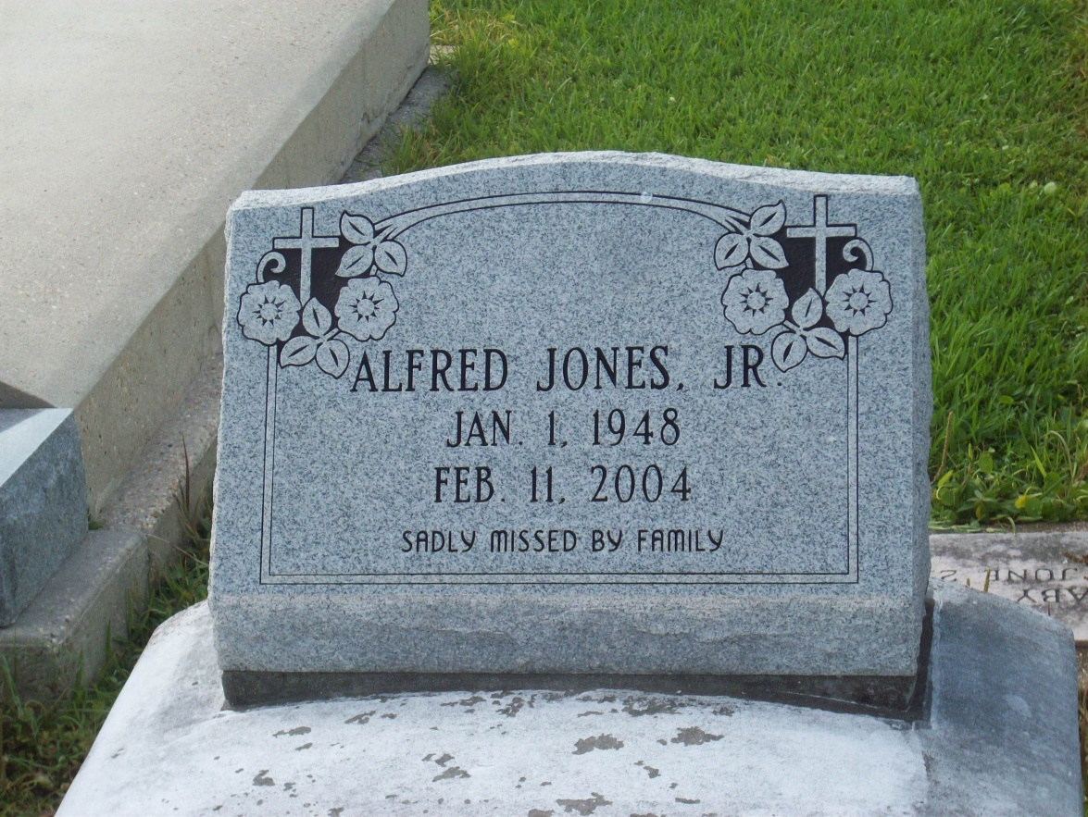

Photo by TMB

Alfred ''Trapper'' Jones, Jr., on Wednesday, February 11, 2004 at Ochsner Foundation Hospital. Son of Rita Jones of Vacherie and the late Alfred Jones, Sr. Father of Nikita, Andrea, Allen and Matthew Jones and Shantrice Minor. Brother of Carnel, Brice, Kenneth, Carla, Adrea and Wendy Jones, Clarise Oubre and Pamela Brown and the late Connie and Stephanie Jones and Elaine Sutherland. Also survived by 2 grandchildren and a host of aunts, uncles, nieces, nephews, other relatives and friends. A native of Vacherie and a resident of Lockport, LA. Age 56 yrs. Mass of Christian Burial on Saturday, February 21, 2004 at 11:00 A.M. at Our Lady of Peace Catholic Church in Vacherie, LA. Interment in the church cemetery. Visitation from 9:00 A.M. to funeral time on Saturday at the church. WILLIAMS & SOUTHALL FUNERAL HOME, Thibodaux, LA. in charge of arrangements.

The Times-Picayune, New Orleans, Louisiana

Feb. 20, 2004