Earl Jones

April 14, 1914 – November 8, 2004

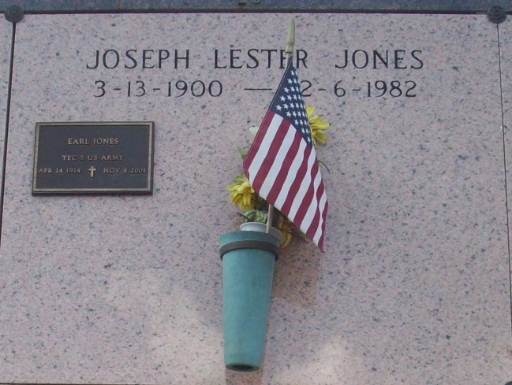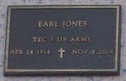

Photos by TMB

Earl Jones, a retired Landscape Gardener, died on Monday, November 8, 2004 at V.A. Hospital of natural causes. He was 90 years old. He was a native of Vacherie, LA and a resident of New Orleans, LA for many years. He was a veteran in the United States Army where he served in World War II, Veterans of Foreign War. His highest rank held was TEC 5. He received a Good Conduct Medal Eameto Medal.  
  
His survivors include: 1 daughter, Josephine N. Mohr; 2 grandchildren: Austin Mohr and JoAnn Tervalon; 5 great-grandchildren; 2 nieces: Melba Waddell and Audrey Moline; a host of nieces, nephews, cousins, other relatives; and friends.  
  
SERVICES WILL BE PRIVATE.   
  
Arrangements by DUPLAIN W. RHODES FUNERAL HOME, 3933 Washington Ave.

Times-Picayune, The (New Orleans, LA) - Wednesday, November 10, 2004

Contributed by Jane Edson