Iris A. Jones

August 4, 1958 – November 24, 2003

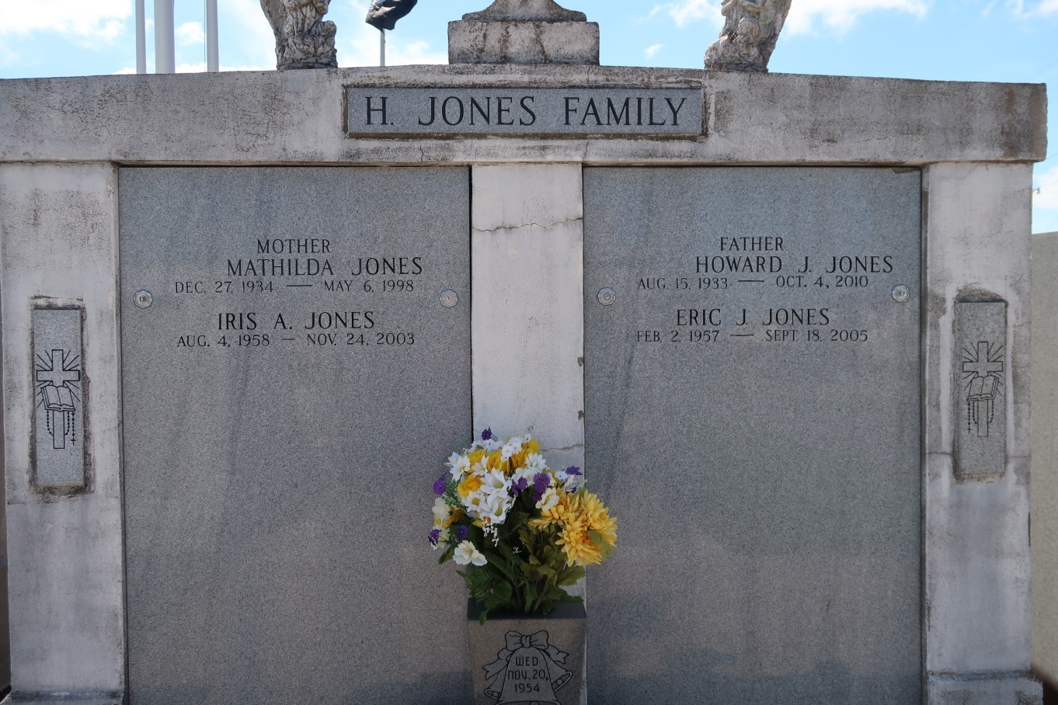

Iris A. Jones departed this life on Monday, November 24, 2003 at River Parish Hospital. Mother of Jaelon Matthews Jones. Daughter of Howard Joseph Jones and the late Mathilda James Jones. Granddaughter of the late Heedley and Agnes James, Noemie and James Jones. Sister of Eric Joseph Jones. Niece of Bessie Piper, Juliana Foucher, Thelma Armand, Jean James, Celeste, Sterling and Joseph James, Joseph J. Jones, Alvin Piper, Sr., Augusta Armand, Rosemond Steib and the late Ester Combre, Rita M. Jones, Vivian Steib and Chester Combre. Devoted friend of Jackie Oubre. Also survived by a host of cousins, godchildren other relatives and friends. Age 45 years, a native and resident of Vacherie, LA. Relatives and friends of the family, also Priests, and Parishioners of Our Lady of Peace Catholic Church and all neighboring churches. Employees of Vacherie Dialysis Center, NNA Dialysis Center, Thibodaux Regional Center, River Parish Hospital, Thibodaux Regional Home Health Care, St. James Home Care and Acadian Ambulance are invited to attend the Mass of Christian Burial from Our Lady of Peace Catholic Church 13281 Hwy. 644 Vacherie, LA on Saturday, November 29, 2003 at 11:00 AM. Father Michael Micelli - Officiating. (NO WAKE). Visitation from 8:00 AM until service. Recitation of the Rosary will begin at 9:00 AM at the above named church. Interment: Our Lady of Peace Catholic Church Cemetery - Vacherie, LA. Family guest book may be signed @ www.legacy.com. Arrangements by DAVIS MORTUARY SERVICE 230 MONROE ST. GRETNA, LA.

The Times-Picayune, New Orleans, Louisiana

Nov. 28, 2003