Rita Nelia (Keller) Jones

September 7, 1927 – April 7, 2014

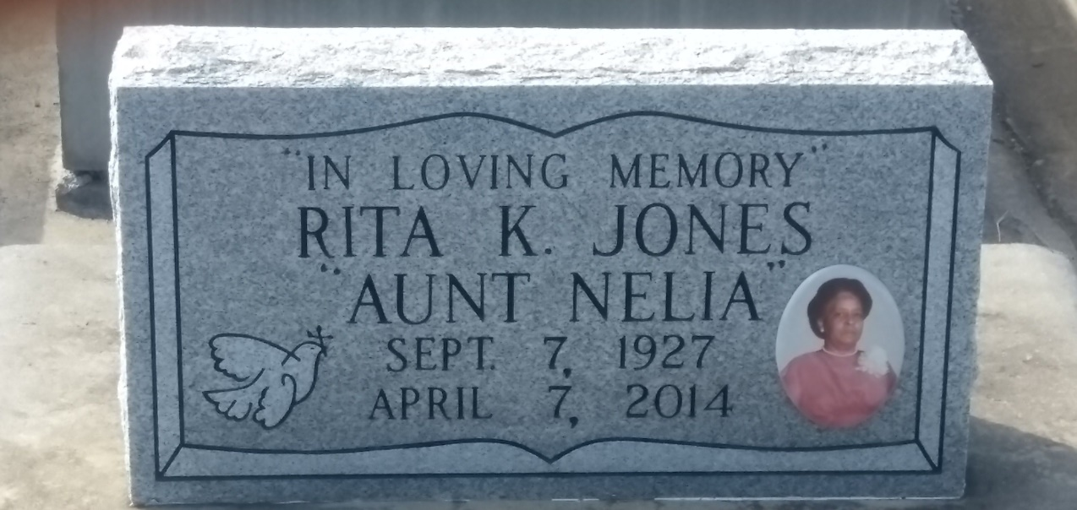

Photo by TMB

Rita Nellia Keller Jones, 86, was born on September 7, 1927 and passed away on April 7, 2014. She was a native and resident of Vacherie, LA. She is survived by her children, Cornel Jones, Clarise Jones, Brice Jones, Kenneth Jones, Pamela Jones Brown, Carla Jones, Andrea Jones, Wendy Jones; brothers & sisters; multiple grandchildren, & great grandchildren. She is preceded in death by her husband, Alfred Jones Sr.; parents, Bathelmie and Malvina Stieb Keller; children, Alfred Jones Jr., Connie Jones, Elaine Jones Sutherland, Stephanie Jones Frye, Carol Jones; brothers and sisters, and grandchild, Mark Jones.

Unknown source