Rose (Osborne) Joseph

April 9, 1916 – January 17, 2007

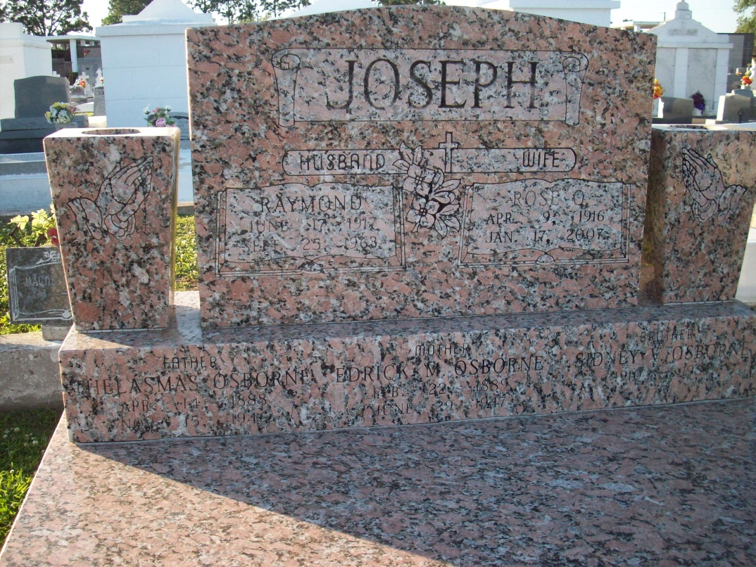

Photo by TMB

Rose Osborne Joseph, age 90 years, at Gretna, LA on Tuesday, January 17, 2007. Wife of the late Raymond Joseph. Sister of the late Girlie Jasmin, Angelina Whaley, Aldonia Adams, Joseph Maurice Osborne, Marie Bastian, Elnora Jones and Sidney Osborne. Daughter of the late Ederick Michelle and Tillsman Osborne. Also survived by nieces, nephews, cousins, great nieces and great nephews.  
  
Relatives and friends of the family are invited to attend the Funeral Mass from St. Rita Catholic Church, 2729 Lowerline Street, New Orleans on Saturday, January 27, 2007 at 10:00 AM with Fr. RicK Day as celebrant. Visitation at the church from 9:00 AM until service time. Interment Our Lady of Peace Cemetery, Vacherie, LA under the direction of Tharp-Sontheimer-Tharp of Metairie. Information: (504) 835-2341.

Times-Picayune, The (New Orleans, LA) - Friday, January 26, 2007

Contributed by Jane Edson