Doretha (Philip) Keller

November 26, 1921 – November 4, 2019

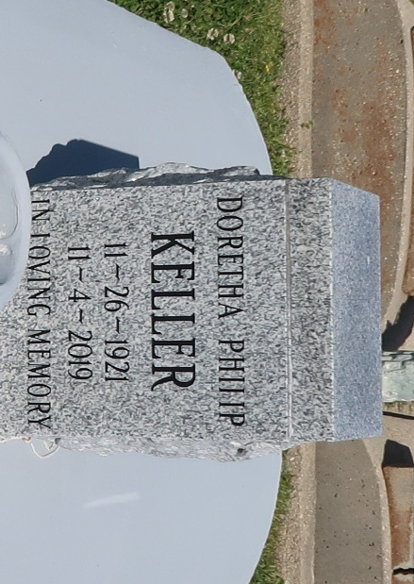

Doretha P. "Maw Maw" Keller was born on November 26. 1921. Daughter of the late Stanislaus Philip and Natalie Saul of Vacherie, La. She married Edmond J. Keller of Vacherie in November 1939.

In the early 1940's they moved to "the city" of New Orleans, La. Life wasn't easy along the way. The depression ended in 1939, just in time for World War II to begin. Doretha lived to witness many historical events; the attack on Pearl Harbor, the end of segregation, the Civil Rights Movement, the Vietnam War, a man landing on the moon and ultimately the election of the first black President, Barack Obama. Doretha became a parishioner of Holy Ghost Catholic Church now known as St. Katharine Drexel Church. There she joined the Sodality and The Knights of Peter Claver, Court 52 and became a lifetime member. Doretha also participated in a number of other religious and social organizations: the Holy Ghost Choir, The Holy Ghost Senior Citizens, the Mercy Endeavors Senior Citizens, and the Good Children's Benevolent Association in Vacherie, La. Doretha spent her last years as a beloved resident of St. Luke's Living Center.

On the morning of Monday, November 4, 2019, God called her home saying "Well done my servant...enter my joy...that you may rest from your labor...your work will follow you. ""Revelation 14:13. Maw Maw entered her eternal home at the age of 97. Maw Maw's memory will forever be cherished by her three children, Edmond, Jr., John, Sr., and Diane Oubre. Two daughters-in-law, Genevieve Favorite Keller and Spring Butler Keller, and one son-in-law, Paul Frank Oubre. Two sisters, Fannie Philip and Catherine Francis (Melvin) and one brother-in-law, Charles Landreaux. Six Grandchildren, V. Antoine Keller (Allison), Bethany Oubre, Erika Johnson, John Keller, Jr., Kelly Oubre, Sr., and Natalie Barnes (John); 10 great grandchildren Madison Keller, Kingston Keller, Maxwell Keller, Kelly Oubre, Jr., Kiersten Keller, Myles Keller, Kailey Johnson, Nicolas Johnson, Tosh Barnes, and Mila Barnes. A host of god-children, nieces, nephews, and cousins.

Beloved family members who preceded her in death are her parents, her husband Edmond Keller, Sr., brothers John, Joseph, and Walter Philip, sisters Pauline Oubre, Eva Landreaux and Theresa Weber, brothers-in-law Ralph Weber and Freddie Oubre, sisters-in-law Dora and Amelia Philip and her grandson Brett Keller.

Relatives and friends of the family, also Priests and Parishioners of St. Katharine Drexel Catholic Church are invited to attend a Memorial Mass at 11:00 AM on Saturday, November 9th at St. Katharine Drexel Catholic Church, 2015 Louisiana Ave. Visitation will be from 10:00 AM until Mass time. Arrangements by D.W. Rhodes Funeral Home. Please visit [www.rhodesfuneral.com](http://www.rhodesfuneral.com/) to share online condolences.

The Times-Picayune, New Orleans, LA

Nov. 6 to Nov. 9, 2019