Equilla M. (Favoroth) Keller

October 8, 1919 – June 11, 2017

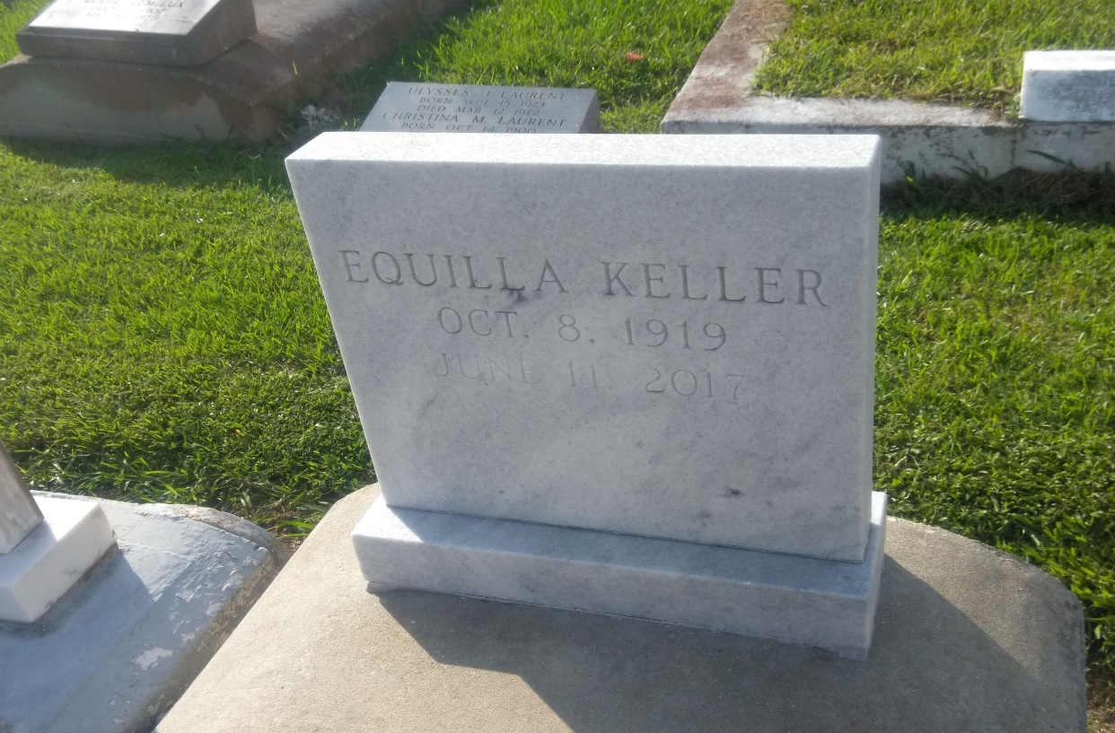

Photo by TMB

Equilla M. Keller departed this life on Sunday, June 11, 2017 at her residence in Vacherie, LA. She was 97, a native of Vacherie, LA. Visiting on Friday, June 16, 2017 at Williams & Southall Funeral Home, 1204 Cleveland St., Thibodaux, LA from 2:00pm to 4:00pm. Visiting on Saturday, June 17, 2017 at Our Lady of Peace Catholic Church, 13281 LA-644, Vacherie, LA from 8:00am to Mass of Christian Burial at 10:00 am. Burial in the church cemetery. Survived by 2 sons, Edward (Odetta) and Lawrence (Betty) Keller; 2 daughters, Rita C. Keller and Lois M. Keller; 1 sister, Nazzie Laurent; 19 grandchildren; a host of great grandchildren, nieces ,nephews, other relatives and friends and 1 great-great grandchild. Preceded in death by her parents, Madeline and Edward Favoroth; husband, Armand Keller; 1 son, Nicholas Keller. Arrangements by Williams & Southall Funeral Home, 1204 Cleveland St., Thibodaux, LA 447-2513. To sign guest book or offer condolences, visit our website at www.williamsandsouthallfuneralhome.com.   
  
Funeral Service Saturday, Jun 17, 2017 10:00 AM OUR LADY OF PEACE CATHOLIC CHURCH 13281 HWY 644 VACHERIE, LOUISIANA 70090

Williams & Southall Funeral Home, Inc., Napoleonville, LA

March 8, 2020