Gayle Marie Keller

1956 – August 25, 2008

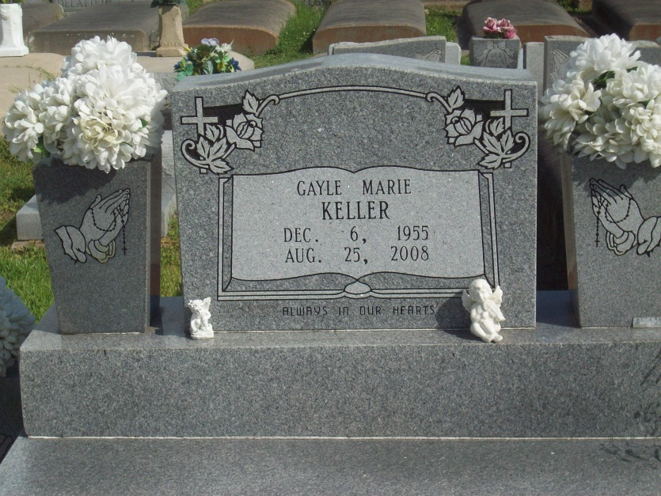

Photo by TMB

Keller, Gayle Marie

A payment management administrator for the Louisiana Department of Social Services, she died at 8:50 a.m. Monday, Aug. 25, 2008, at Ochsner Medical Center. She was 52, a resident of Baton Rouge and a native of Vacherie. Visiting at Our Lady of Peace Catholic Church, 13281 La. 644, Vacherie, on Friday, Aug. 29, from 9 a.m. to 11 a.m., with recitation of the rosary at 9:30 a.m. Religious service at the church at 11 a.m. Friday, conducted by the Rev. Louis T. Oubre. Interment in church cemetery. Her family was her life and she was a dedicated mother, daughter and sister. Survived by her parents, Charles and Septemia Gibson Keller; son, Devin Marcus; sisters, Theresa Keller, Peggy Keller-Kelly, Maxine Keller-Spurlock and Lisa G. Keller; brother, Troy A. Keller; and brothers-in-law, Malcolm Kelly and Alphonse Spurlock Jr. Preceded in death by her siblings, Charles Jr., Kenneth, Ricky and Linda Ann. She graduated from Southern University in 1976 with a bachelor's degree in accounting. Arrangements by Baloney Funeral Home LLC, Garyville.

Advocate, The (Baton Rouge, LA) - Friday, August 29, 2008