Joseph Arthur Keller

April 13, 1917 – January 28, 1994

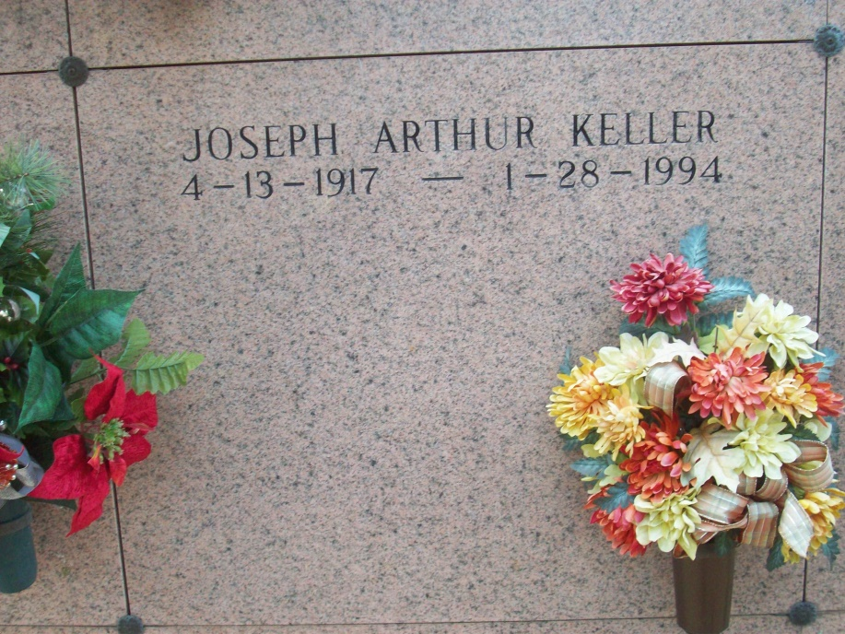

Photo by TMB

A Mass of Christian burial was celebrated at 10 a.m. today at Our Lady of Peace Chatholic Church in Vacherie for Joseph Arthur Keller, 76, a native and resident of Vacherie, who died at 10:50 a.m. Friday, Jan. 28, 1994. Burial was in the church cemetery.

He was the brother of Julius and Paul Keller, Dorothy K. Laurent, Rita K. Jones, Dora K. Chapin, Genevieve K. Magee and Maria K. Harris.

He was precede in death by his parents, Barthelemew and Malvina Steib Keller; and two brothers, George and Maury Keller.

Thibodaux Funeral Home was in charge of arrangements.

Unknown source