Linda Ann Keller

February 20, 1949 – May 12, 2002

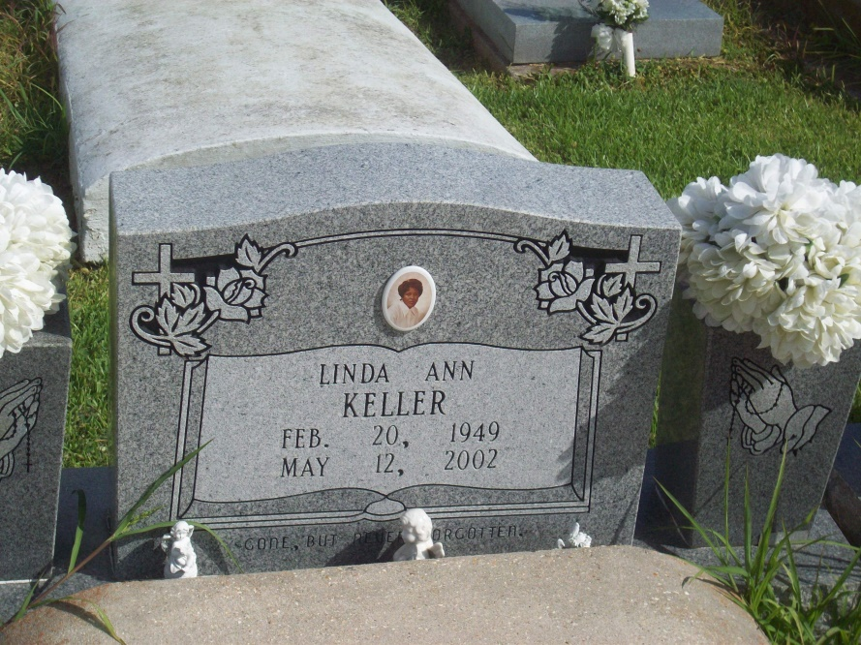

Photo by TMB

Linda Ann Keller of Vacherie, LA at Ochsner Hospital on Sunday, May 12, 2002 at 12:47 p.m. Daughter of Charles and Septemia Keller. Mother of Demetrice M. Lewis and Adele M. Keller. Mother-in-law of Shawn Lewis. Sister of Theresa, Gayle and Lisa Keller of Baton Rouge, LA, Peggy Kelly and Maxine Spurlock of New Orleans, LA, Ricky and Troy Keller of Vacherie, LA, the late Kenneth and Charles Keller, Jr. Sister-in-law of Malcolm Kelly and Alphonse Spurlock. Grandmother of DeShawn, Shawn Jr. and Shane. Devoted friend of Gerald Joseph. Also survived by a host aunts, uncles, nieces, nephews, cousins, other relatives and friends. A native and lifelong resident of Vacherie, LA. Age 53 years.  
  
Relatives and friends of the family; also priest and parishioners of Our Lady of Peace Catholic Church are invited to attend a Mass of Christian Burial on Wednesday, May 15, 2002 at 11:00 a.m. from Our Lady of Peace Catholic Church, Vacherie, LA. Father Louis Tim Oubre - celebrated. Interment Church Cemetery. Visitation at the Church after 8:00 a.m.  
  
THE BALONEY FUNERAL HOME in charge of arrangements.

Times-Picayune, The (New Orleans, LA)

Tuesday, May 14, 2002