Lionel Keller Sr.

July 5, 1958 – July 18, 2009

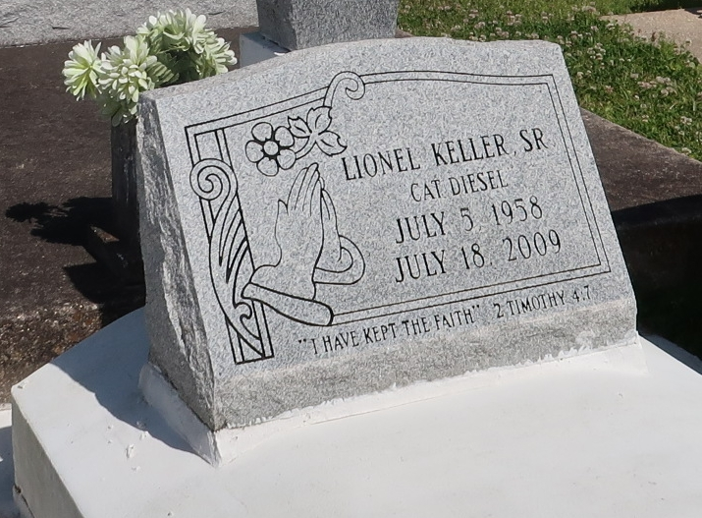

Photo by TMB

Lionel (Cat Diesel) Keller Sr. of Vacherie, La. on Saturday. July 18, 2009 at Thibodaux Regional Medical Center. A native and resident of Vacherie, La. Age 51 yrs.  
  
Son of Elix and Geraldine Keller. Father of Nakita Evans, Talvis Sr., Lionel Jr. Brother of Elix Jr., Elton, Clifford, Sidney, Paul Keller, Paulette Steib, Shelia Hilaire, Samantha Phenix. Devoted friend of Cynthia Robinson, and her daughter Rankia Robinson. Survived by (9) grandchildren,.  
  
Mass of Christian Burial on Friday, July 24, 2009 at 11:00am from the Our Lady of Peace Catholic Church, Vacherie, La. Interment church cemetery.

Unknown source