Oralee Marie (Laurent) Keller

April 26, 1936 - February 20, 2001

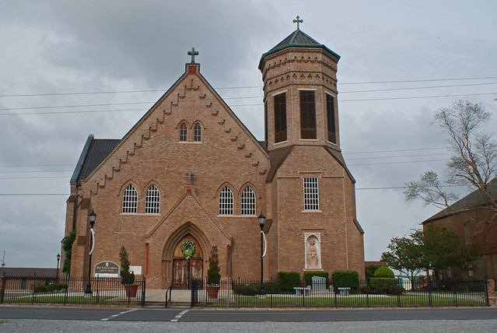

Oralee Marie Laurent Keller, 64

A homemaker, she died Monday, Feb. 20, 2001, at Thibodaux Regional Medical Center. She was 64 and a native and resident of Vacherie. Visitation at Our Lady of Peace Catholic Church, Vacherie, from 7 a.m. Saturday until Mass of Christian Burial at 10:30 a.m., celebrated by the Rev. Henry Gautreau and the Rev. Tim Oubre. Entombment in church mausoleum. Survived by her husband, Captain Gufielle Keller; four daughters, Gwendolyn Keller, Houma, and Barbara, Mary and Vera Keller, all of Vacherie; four sons, Calvin Keller, McAllister, Okla., and Patrick, Hardin and Cornell Keller, all of Vacherie; a brother, Norris Laurent Sr.; three sisters, Elizabeth Laurent and Geraldine Smith, both of Vacherie, and Shirley Steib, Marrero; two daughters-in-law, Jeanette Keller, McAllister, Okla., and Alisha Kim Keller, Vacherie; a stepdaughter, Grace Steptore, Convent; 12 grandchildren; six great-grandchildren; three brothers-in-law; six sisters-in-law; a son-in-law; and many nieces, nephews, other relatives and friends. Preceded in death by her parents, Maurice and Amelia Lemieux Laurent. Williams & Southall Funeral Home, Napoleonville, in charge of arrangements.

Advocate, The (Baton Rouge, LA)

Friday, February 23, 2001