Paul B. Keller

April 28, 1934 – October 22, 2014

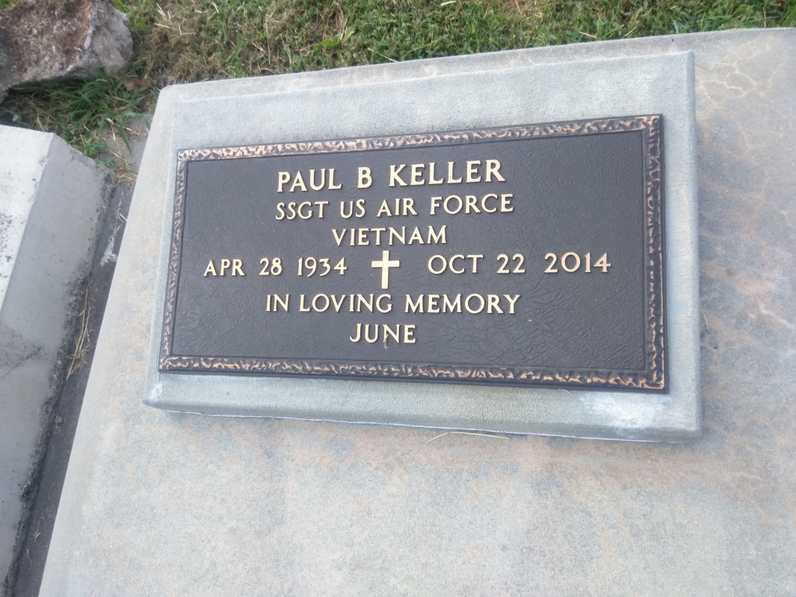

Photo by TMB

SSgt. Paul B. Keller (Ret.), 80, a native of Vacherie, LA and long time resident of Sacramento, CA, transitioned into eternal peace Wednesday, October 22, 2014, in Sacramento, CA. Visitation will be at Our Lady of Peace in Vacherie, LA on Friday, October 31, 2014 from 9:00AM till funeral time. A Mass of Christian Burial will take place at 11:00 AM at the church. Interment will be in the church cemetery. SSgt. Paul Keller, a United States Air Force veteran, retired honorably after twenty years of service to his country. SSgt. Keller served meritoriously during the Vietnam War. SSgt. Keller was betrothed to Jacqueline J. Alston on March 1, 1958, in Omaha, Nebraska. A union/marriage of 56 years, SSgt. Keller and spouse raised five daughters during his military service throughout the continental United States and overseas. SSgt. Keller enjoyed fishing, camping and listening to jazz music. Additionally during leisure time SSgt. Keller was fond of football and baseball. Most importantly, SSgt. Keller was a man of faith represented by his devotion to Catholicism. In addition to his loving wife, Jacqueline J. Keller, SSgt. Keller leaves his memories with five daughters, Patryce Keller (Ervin Bush) of Sacramento, CA., Natalie Keller of Sacramento, CA, Kimberley (Eric) Satterwhite of Sacramento, CA, Tracy (Stan) Eurie of Roseville, CA, Stacy (John) Jones of Roseville, CA, grandchildren Brandon, Kyle and Princeton Bush, Terrell Anderson, Amiyr and Ariel Kaashif, Tevin, Ashliegh, Shaei and Nathan Eurie, Tiara Keller and Chantel Jones, sisters Genevieve K. Magee of Bogalusa, LA., and Maria (Agneal) K. Harris of Houma, LA, and a host of other nieces, nephews, cousins, other relatives and friends. SSgt. Keller is preceded in death by; parents, Barthelmy and Malvina Steib Keller, four brothers, Arthur Keller, George Keller, Murray Keller and Julius Keller, three sisters, Dora K. Chopin, Dorothy K. Laurent and Rita Jones, one grandchild, John Zander Jones III. Thibodaux Funeral Home Inc. is in charge of arrangements.

Published in The New Orleans Advocate from Oct. 29 to Oct. 30, 2014.