Veronica (Freeman) Keller

December 14, 1920 – August 18, 2001

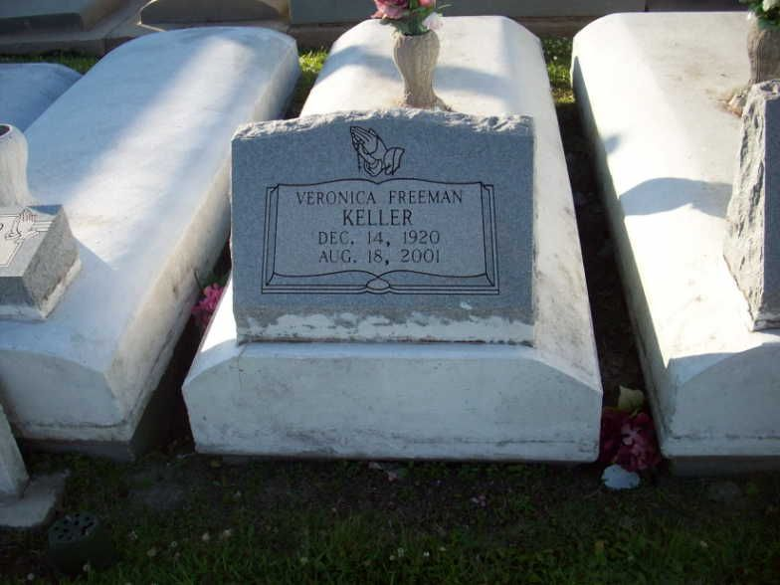

Photo by TMB

Veronica F. Keller, a homemaker, died Saturday August 18, 2001 at West Jefferson Medical Center. She was 80. Mrs. Keller was born in Vacherie and lived in Marrero for the past 54 years. She was employed at St. Rosalie and Infant Jesus of Prague churches. She was a member of the Fourth Degree Knights of Peter Claver Ladies of Grace, the Knights of Peter Claver Ladies Auxiliary St. Rita Court No. 36, Good Shepard Ministry and the Ladies of the 70s. She also was a Eucharistic minister. Survivors include a son, Jerome P. Keller; five daughters, Hildredge K. Gibson of Dallas, Cathy Scott of Monroe, Nellie Barthelomew, Madeline K. Bridgewater and Kathleen K. Payadue; a brother, Joseph Octave Freeman; two sisters, Julia F. Domino and Melanie F. Dumas; 17 grandchildren; and 25 great-grandchildren.

Unknown source

\*\*\*\*\*

Veronica Freeman Keller at West Jefferson Medical Center on Saturday, August 18, 2001 at 3:45 P.M. Beloved wife of the late Lennis Keller. Devoted mother of Nellie K. Barthelomew of Marrero, La., Hildredge K. Gibson of Dallas, Texas, Madeline K. Bridgewater of Marrero, La., Jerome Keller of Marrero, La., Cathy K. Scott of Monroe, La., Katheleen K. Payadue of Marrero, La. and the late Merlin Keller. Daughter of the late Melanie Steib Freeman and Alcee Freeman, Sr. Sister of Melanie F. Dumas, Julia F. Domino, Joseph Octave Freeman and the late Agnes F. James and Alcee Freeman, Jr. Also survived by 17 grandchildren, 25 great grandchildren, 7 sisters in law, 3 brothers in law, 1 daughter in law, 5 sons in law and a host of nieces, nephews, cousins other relatives and friends. Age: 80 years. A native of Vacherie, La. and a resident of Marrero, La.  
 Relatives and friends of the family, also Priest and Parishioners of St. Joseph The Worker Catholic Church and all neighboring churches, Members of Fourth Degree Knights of Peter Claver Ladies of Grace, Knights of Peter Claver Ladies Auxiliary, St. Rita Court No. 36, Knights of Peter Claver St. Joseph The Worker Council and Court No. 267, St Joseph The Worker Catholic School, Lincoln High School, Dallas, TX., Wynhoven Health Care Center, Elmwood Drydock and Repair, Louisiana Office of Public Health Immunization Program and Fresenius Medical Care are invited to attend the Mass of Christian Burial from St. Joseph The Worker Catholic Church, 455 Ames Blvd., Marrero, La. on Saturday, August 25, 2001 at 10:00 A.M. Viewing of remains from 8:00 A.M. until 9:45 A.M. at the above named church. Father Paul McQullen-Celebrant S.S.E. Recitation of the Rosary from Davis Mortuary Service, 6820 W. B. Expressway, Marrero, La. on Friday, August 24, 2001 at 6:30 P.M. Viewing of the remains from 6:00 P.M until 9:00 P.M at the above named chapel. Interment: Our Lady of Peace Cemetery - Vacherie, La.  
 Arrangements By: Davis Mortuary Service, 230 Monroe St., Gretna, La.

Times-Picayune, The (New Orleans, LA)

Friday, August 24, 2001