Ethel (Folse) Kliebert

October 6, 1929 – October 30, 2011

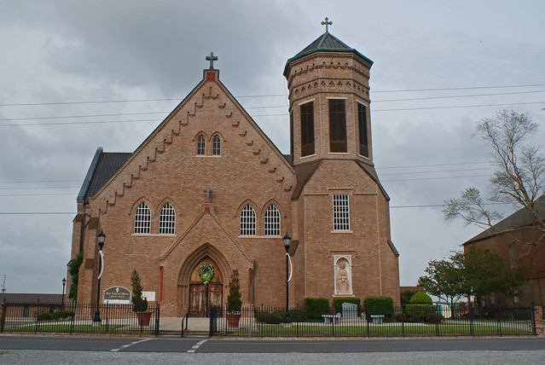

Ethel Folse Kliebert passed away on October 30, 2011 at 12:16 AM. She was 82. Born on October 6, 1929, she was a native and resident of Vacherie, LA. She is survived by her sister Hazel F. Orgeron, her sons Kirk F. (Debbie) and Owen J. (Regina), seven grandchildren and 5 great-grandchildren. She is preceded in death by her husband Mark F. Kliebert, her parents Julie M. Rome Folse and Morris Folse and her daughter, Judy R. Hotard. Visitation is from 9AM until 11AM on Wednesday, November 2, 2011 at Our Lady of Peach Catholic Church in Vacherie, LA. Mass of Christian Burial will follow. Burial will be at Our Lady of Peace. Landry's Funeral Home Inc., Thibodeaux, LA, in charge of arrangements.

Times Picayune, New Orleans, LA; November 1, 2011