Marie Angele (Mury) Kliebert

January 20, 1847 – September 6, 1934

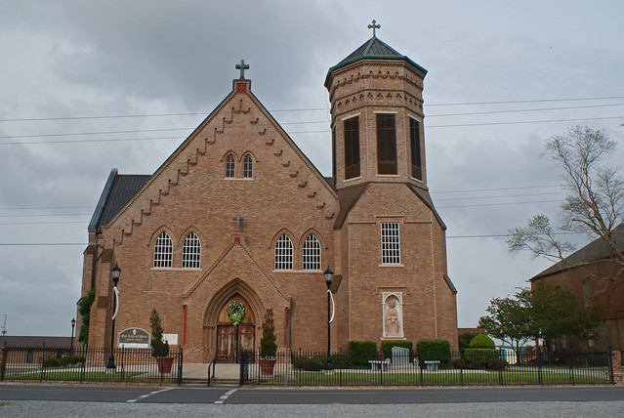

Name: Angel Mary Kleibert   
Death Date: 06 Sep 1934   
Death Place: Vacherie, St. James, Louisiana   
Gender: Female   
Race (original): W   
Race (standardized): White   
Age: 88   
Estimated Birth Year: 1846   
Birth Place: Vacherie, Louisiana   
Marital Status: Widowed   
Spouse's Name: Frederick Kleibert   
Father's Name: Armand Ulury   
Mother's Name: Angelina Luquette