Dudley John Labat

September 14, 1928 – July 24, 2004

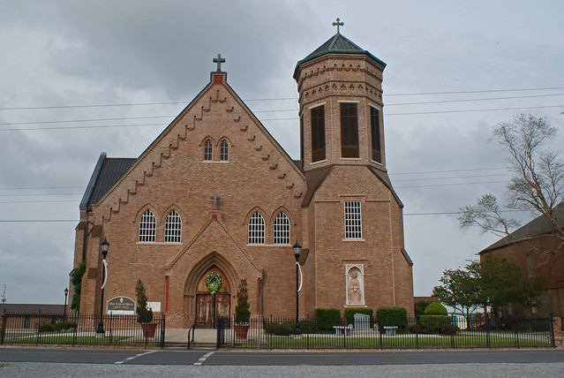

A retired machinist for Graugnard Farms Inc. and a resident of St. James, was 75 and a native of Vacherie.   
 He was a U.S. Army veteran of the Korean conflict.   
 Survived by a daughter and son-in-law, Rosemary and Michael Sullivan, Many; two sons and daughters-in-law, Gerard and Nancy Labat of Milton and Francis and Ann Labat of Houma; a brother, Lester Labat of Chalmette; grandchildren, Elizabeth and Jody LeBlanc, Chrissie and Stacy Albert, Christopher and Patrick Labat and Becky, Adam and John Sullivan; and three great-grandchildren, Spencer and Madison LeBlanc and Payton Albert.   
 Preceded in death by his wife, Marguerite Mary Abadie Labat; a daughter, Wanda Ann LaBat; parents, Richard and Selma Falgoust Labat; two sisters, Alice Becnel and Mae Simon; and brothers, Richard "Ikie," Rumsey, Claude, Sidney "Beb" and Ray Labat.   
 He was a member of Vacherie Knights of Columbus Council 1514 for 57 years.

Unknown source