Francile (Baker) Labat

January 31, 1934 – December 28, 2013

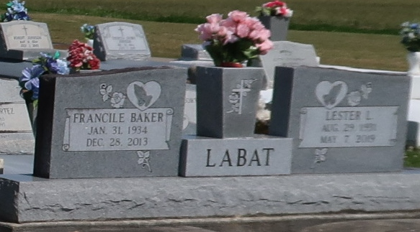

Francile Baker Labat passed away peacefully at her home on Saturday, December 28, 2013 at the age of 79. She was the cherished wife of 59 years to Lester L. Labat. Loving mother of Jenny (Curry) Clement, Kathy (Allen) Bourgeois, Linda Taylor, Larry (Lisa) Labat, Dennis Labat, Russell Labat and Joseph (Wendy) Labat.   
 She is also survived and fondly remembered by her sister, Margaret B. Lucas, her grandchildren, Albert (Stephanie), Bradley (Erika), Byron (Brandy), Melissa (Steven), Heidi (Christopher), Dustin, Jana, Evan, Trevor, Madison & Gavin, her great grandchildren, Anthony, Zackary, Brody, Jase, Gabrielle, Hunter, Shelby & Sophia; along with many nieces, nephews, cousins and dear friends.   
 She was preceded in death by her parents, James and Ida Williams Baker, her brothers and sisters, and her dear great grandchild, James Bourgeois.   
 Francile was a native of Emerson, AR, a longtime resident of St. Bernard Parish and a current resident of Vacherie, LA. She was well loved and will be forever remembered as a loving and loyal wife, mother, grandmother, sister, and a friend to many, who treasured her family.  
 Relatives and friends are invited to attend a visitation to be held at OUR LADY OF PEACE CATHOLIC CHURCH, 13281 LA 644, Vacherie, LA on Tuesday, December 31st from 9:00AM – 11:00AM, followed by a Funeral Mass beginning at 11:00AM. Burial will take place in Our Lady of Peace Cemetery.

Unknown source