Irena (Rodrigue) Lassere Labat

1925 – March 8, 2010

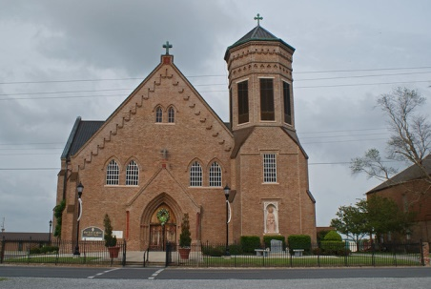

Irena Rodrigue Lassere Labat, 85, a resident of Vacherie, passed away in Thibodaux at Lafourche Home for the Aged on Monday, March 8, 2010.   
 Visitation will be from 8 a.m. to funeral time Wednesday at Our Lady of Peace Catholic Church in Vacherie. Mass will be 11 a.m. Wednesday at the church, conducted by the Rev. Michael Miceli, with interment in the church mausoleum.   
 She is survived by two daughters and sons-in-law, Marion and Bobby Legendre of Gonzales, and Arlene Labat Hebert and Wayne Hebert of Louisville, Ky.; three sons and daughters-in-law, Allen and Diane Lassere of River Ridge, Howard and Norma Labat of Vacherie, and Erwin Labat of Vacherie; one sister, Dolores Robichaux of Raceland; two brothers, Alvin Rodrigue of Chackbay, and Euris Rodrigue of Slidell; 11 grandchildren; and six great-grandchildren.   
 She was preceded in death by her husbands, Joseph Lassere, and Claude P. Labat; her parents, Aline Mars Rodrigue and Sevin Rodrigue; and two great-grandchildren, Austin "Boo Boo" Ford and Ashton Ford. Pallbearers will be Ricky Legendre, Taylor Ford, Todd Lassere, Craig Lassere, Paul Labat, and John Labat. She was a member of the Catholic Daughters, Ladies Altar Society. She was a retired homemaker, avid artist and gardener.   
 "Eye has not seen, ear has not heard, nor has it so much as dawned on man what God has prepared for those who love him." 1 Corinthians 2:9   
 Ourso Funeral Home of Gonzales is in charge of arrangements.

Unknown source