Edianne (Brack) Landry

November 24, 1910 – May 5, 2011

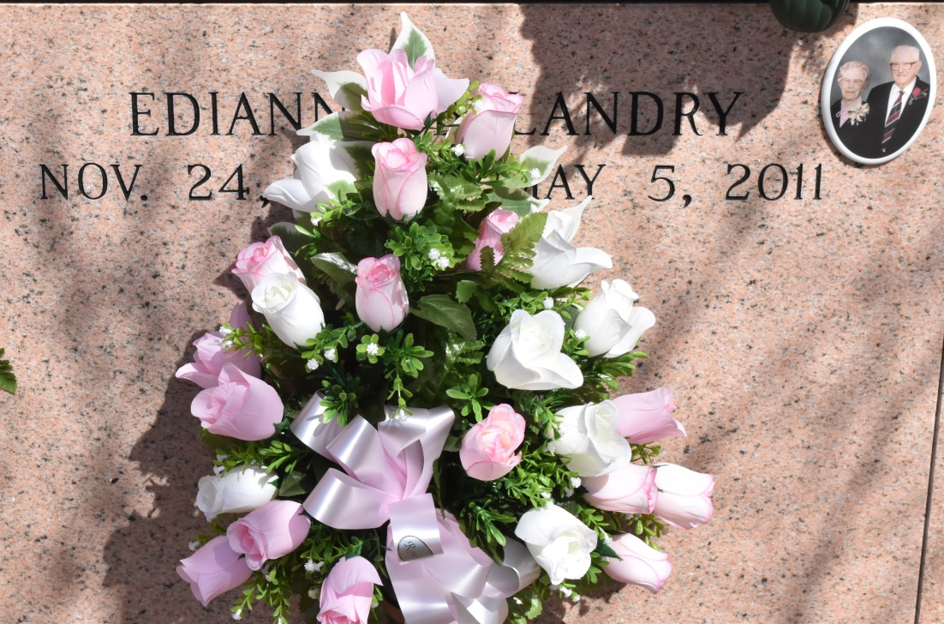

Edianne Brock Landry, 100, a native and resident of Vacherie, died Thursday, May 5, 2011.  
 Visitation will be from 9 a.m. to funeral time Saturday at Our Lady of Peace in Vacherie, with burial in the church cemetery.  
 She is survived by three daughters, Rose L. Falgout and husband, J.B., Gloria L. Boe and husband, Floyd, and Dorothy L. Guillot and husband, Denny; 14 grandchildren; 31 great-grandchildren; and 16 great-great-grandchildren.  
 She was preceded in death by her husband, Ulger Landry; her parents, Charles Brock and Edna Hebert Brock; four brothers, William, Everest, Louis, and Charles Brock; and three sisters, Adles B. Benoit, Edise B. Bourg and Denise Chapaton.  
 Landry's Funeral Home is in charge of arrangements.

Houma Today, Terrebonne Parish, LA

May 6 to May 7, 2011.